**SMARTCROP ADVISOR: PREDICTIVE CROP RECOMMENDATION & AGRO-MANAGEMENT SYSTEM USING RANDOM FOREST AND AGRIBOT CHAT ASSISTANT**

**ABSTRACT**

# Agriculture plays a vital role in sustaining human life, yet farmers often face difficulties in choosing the right crop due to unpredictable weather, soil diversity, and improper nutrient management. To address these challenges, this project presents **SmartCrop Advisor: Predictive Crop Recommendation and Agro-Management System using Random Forest and AgriBot Chat Assistant**. The system analyzes critical soil and climatic parameters such as Nitrogen (N), Phosphorus (P), Potassium (K), pH, rainfall, temperature, and humidity to predict the most suitable crop for cultivation using the **Random Forest algorithm**. A **Django-based web platform** is developed to offer easy accessibility, where users can input soil data and receive intelligent crop recommendations. Additionally, the system integrates **AgriBot**, a smart conversational assistant that interacts with users in natural language to provide instant agricultural advice on fertilizers, pest control, soil health, irrigation, and marketing. Together, these components form a comprehensive decision-support system that enhances crop productivity, optimizes resources, and promotes sustainable farming practices.

# **Keywords:** Crop Recommendation, Random Forest, Machine Learning, AgriBot, Chatbot, Django, Agro-Management, Smart Farming, Precision Agriculture.

# **CHAPTER 1: INTRODUCTION**

# **1.1 Introduction**

# Agriculture forms the backbone of many economies, especially in developing countries, providing employment and ensuring food security. However, modern farming is influenced by numerous unpredictable factors such as climate variability, soil fertility, and rainfall patterns. Farmers often rely on experience-based decisions, which may lead to poor crop selection, low yield, and economic losses. With technological advancements, the integration of data science and artificial intelligence has created new opportunities to revolutionize agricultural decision-making.

# This project, **SmartCrop Advisor**, aims to transform traditional farming into a data-driven, intelligent process. It employs the **Random Forest algorithm**, a powerful ensemble machine-learning model, to recommend the most suitable crop based on key soil and weather parameters such as NPK levels, pH, humidity, temperature, and rainfall. The system is built on a **Django web framework**, making it easily accessible to farmers and agricultural professionals. Moreover, the inclusion of **AgriBot Chat Assistant** enables real-time user interaction, offering advice on fertilizers, pest control, and best farming practices through a natural language interface. By combining predictive analytics with conversational AI, SmartCrop Advisor serves as a complete digital companion for farmers, promoting sustainable and profitable agriculture.

# **1.2 Problem Statement**

# Traditional farming methods rely heavily on human experience and intuition, which often fail to account for the complex relationships between soil composition, weather conditions, and crop requirements. Farmers face significant challenges in determining the most suitable crop for their land due to limited access to expert guidance and scientific analysis. Inaccurate crop selection can result in lower yields, soil degradation, and inefficient use of fertilizers and water resources.

# Furthermore, farmers frequently lack immediate access to agricultural information or expert consultations, especially in rural areas. As a result, they struggle to make timely decisions related to crop choice, fertilizer dosage, pest management, and marketing strategies. There is a pressing need for an intelligent system that not only analyzes environmental and soil data but also communicates directly with farmers in an easy-to-understand, interactive manner.

# The **SmartCrop Advisor** system addresses this gap by using a **Random Forest-based prediction model** to recommend the best crop for specific soil and weather conditions. Additionally, the **AgriBot Chat Assistant** provides instant responses to agricultural queries, offering farmers a virtual expert accessible anytime, thereby reducing dependency on manual advice and improving farming outcomes.

# **1.3 Research Motivation**

# The motivation for developing the **SmartCrop Advisor** system arises from the growing need to integrate modern technology into agriculture to improve decision-making and productivity. Many farmers are unaware of the scientific basis behind crop selection and fertilizer usage, leading to inefficient farming practices. As climate change increasingly impacts agricultural yield, there is an urgent demand for intelligent systems that can adapt to varying environmental conditions and guide farmers effectively.

# Machine learning, particularly the **Random Forest algorithm**, has proven to be reliable in analyzing large datasets and handling complex, non-linear relationships between multiple agricultural parameters. This capability inspired the development of a system that can process soil and climate data to predict the most suitable crops with high accuracy.

# Moreover, introducing an **interactive AgriBot assistant** enhances the system’s usability, allowing farmers to access information in a conversational format. This combination of prediction and communication bridges the knowledge gap between technology and farmers. The motivation is to create a **comprehensive agro-management tool** that empowers farmers with real-time, data-driven insights, improves crop yield, reduces input costs, and fosters sustainable farming for future generations.

# **1.4 Applications**

# The **SmartCrop Advisor** system has wide applications in both individual and institutional agricultural contexts. For farmers, it serves as a **personalized digital advisor** that provides intelligent crop recommendations based on soil and environmental conditions. By integrating **machine learning models** with real-time user input, it helps farmers make informed decisions on what to plant, when to irrigate, and which fertilizers to use, thereby increasing yield and reducing resource wastage.

# Agricultural organizations and government bodies can use the system for **policy formulation, soil health monitoring, and precision farming** initiatives. The **AgriBot Chat Assistant** can be deployed in local languages to offer 24/7 agricultural guidance, promoting awareness about modern farming techniques, government schemes, and market trends. The system can also be extended for educational purposes in agricultural universities, helping students understand the role of artificial intelligence in sustainable farming.

# Furthermore, the predictive and conversational capabilities can be integrated into **mobile apps, IoT devices, and smart irrigation systems** to support precision agriculture. Overall, the SmartCrop Advisor system has the potential to revolutionize the farming ecosystem by combining data analytics, intelligent decision-making, and interactive assistance to create a more sustainable and efficient agricultural future.

# **LITERATURE SURVEY**

**Aravind & Ashok Kumar (2020)**

Aravind and Ashok Kumar (2020) proposed a crop recommendation system designed for precision agriculture by employing the Random Forest algorithm. Their work emphasizes the importance of analyzing soil and environmental parameters such as nitrogen, phosphorus, potassium, pH, temperature, and rainfall to provide accurate crop suggestions to farmers. The system leverages Random Forest due to its ability to handle non-linear relationships and high-dimensional data effectively, making it suitable for agricultural datasets that often contain noisy and diverse features. The study highlights how traditional farming practices based on intuition and experience can be replaced with data-driven approaches to improve productivity. Their model demonstrates significant accuracy in crop prediction, illustrating the potential of integrating machine learning into agro-management. The findings contribute to advancing decision support systems in agriculture, offering farmers scientific insights that can lead to optimized yield. This work is directly relevant to projects focusing on crop recommendation and precision farming.

**Khaki & Wang (2019)**

Khaki and Wang (2019) explored the use of deep neural networks for crop yield prediction, showcasing the growing role of deep learning in precision agriculture. Their approach focused on analyzing historical yield data alongside environmental and soil parameters to model complex, non-linear interactions that traditional statistical methods often fail to capture. By leveraging the strengths of deep neural networks, the study achieved superior accuracy compared to conventional machine learning models, underlining the capacity of deep learning to adapt to large-scale agricultural datasets. The research also highlighted the challenges of overfitting and computational demand, offering strategies such as regularization and hyperparameter tuning to mitigate these issues. This work contributes significantly to the literature on agricultural prediction models, demonstrating how advanced AI methods can transform yield forecasting. It forms a foundation for future systems that integrate neural networks with real-time agro-data, enhancing farmers’ decision-making in crop management.

**Singh & Misra (2017)**

Singh and Misra (2017) presented a method for detecting unhealthy regions of plant leaves using image processing techniques combined with genetic algorithms. Their research addresses the problem of plant disease identification, a critical factor influencing crop yield and overall agricultural productivity. The proposed system involves preprocessing plant leaf images, extracting relevant features, and applying genetic algorithms to classify diseased and healthy regions accurately. The study emphasizes how traditional visual inspection methods are error-prone and time-consuming, while automated approaches can provide faster and more reliable results. By integrating evolutionary computation, the framework enhances the robustness and accuracy of disease detection. This contribution is significant in the context of precision farming, where early detection of plant health issues is essential to minimize crop losses. Their methodology illustrates the potential of combining computer vision with optimization algorithms for effective agricultural monitoring, serving as a reference for AI-based plant health diagnostics.

**Ghosal et al. (2018)**

Ghosal et al. (2018) proposed an explainable deep machine vision framework for plant stress phenotyping, addressing the critical issue of interpretability in AI models. Their study applied convolutional neural networks (CNNs) to analyze plant stress responses from imaging data, enabling accurate detection and classification of stress factors. Unlike many black-box approaches, the framework incorporated explainability features that allowed researchers to understand which image regions influenced the model’s decisions, thereby increasing trust in the predictions. The system demonstrated effectiveness in detecting multiple stress types, highlighting the potential of deep learning in advancing plant science research. By bridging the gap between predictive accuracy and interpretability, the study contributes both to computational agriculture and biological understanding. This work is valuable in developing intelligent crop monitoring systems, as it emphasizes not only accuracy but also transparency, ensuring AI-driven recommendations can be validated and trusted in practical agricultural settings.

**Chlingaryan, Sukkarieh & Whelan (2018)**

Chlingaryan, Sukkarieh, and Whelan (2018) reviewed machine learning approaches for crop yield prediction and nitrogen status estimation, highlighting the significance of data-driven techniques in precision agriculture. Their study analyzed a range of supervised learning algorithms, including Random Forest, Support Vector Machines, and neural networks, applied to remotely sensed and field-level data. They emphasized the importance of integrating spectral indices, soil parameters, and climatic variables to enhance predictive accuracy. The review outlined the advantages of machine learning over traditional statistical models, particularly in handling large datasets with complex feature interactions. Additionally, the study identified challenges such as data quality, feature selection, and model generalization across diverse agricultural contexts. Their work underscores the potential of machine learning to optimize resource usage and support decision-making in crop management. This review serves as a strong foundation for research projects focusing on agricultural prediction models, guiding the choice of algorithms and data integration strategies.

**Liakos et al. (2018)**

Liakos et al. (2018) presented a comprehensive review on the applications of machine learning in agriculture, synthesizing research progress across crop monitoring, disease detection, yield prediction, and resource optimization. Their work categorized machine learning applications into supervised, unsupervised, and reinforcement learning, demonstrating the versatility of these methods in addressing diverse agricultural challenges. The review highlighted successful applications of algorithms such as Random Forest, k-means clustering, and deep neural networks in real-world farming contexts. Moreover, it discussed the role of emerging technologies like IoT and remote sensing in supplying high-quality data for machine learning models. Key challenges identified include the scarcity of labeled datasets, computational costs, and the need for explainable AI in critical agricultural decisions. This study is particularly relevant as it positions machine learning as a transformative tool for sustainable farming. It provides a holistic overview that guides researchers and practitioners toward developing intelligent, data-driven agricultural systems.

**Alam et al. (2020)**

Alam et al. (2020) developed a smart agriculture monitoring system that integrates IoT sensors with machine learning to enhance real-time crop and field management. The system collects data on soil moisture, temperature, humidity, and nutrient levels through IoT devices and applies machine learning algorithms to predict crop health and recommend actions. Their research highlights the importance of connectivity and automation in modern agriculture, where timely insights can significantly improve productivity. By combining IoT with predictive analytics, the system provides farmers with actionable intelligence on irrigation, fertilization, and disease prevention. The study demonstrates improved efficiency and resource management, particularly for water and fertilizer use. This hybrid approach showcases the future of precision agriculture, where physical sensing technologies and AI-based analysis work together to deliver sustainable solutions. Their work directly supports the development of integrated platforms that combine environmental sensing with machine learning for crop recommendation and farm management.

**CHAPTER 3: EXISTING SYSTEM**

**3.1 Existing System**

In traditional agricultural practices, farmers primarily depend on their experience, intuition, and ancestral knowledge to decide which crops to cultivate. These decisions are influenced by observable factors such as past weather patterns, visual soil assessment, and local community practices. While such methods may have worked in the past, they lack precision and adaptability in the face of modern agricultural challenges such as climate variability, soil degradation, and increasing demand for productivity.

The **manual system** involves physically examining the soil texture, color, and moisture and making estimations about its fertility. Farmers often depend on periodic soil testing, which is limited in scope and frequency, providing only a partial understanding of soil health. Similarly, fertilizer application and irrigation decisions are made through trial-and-error methods, often leading to overuse or underuse of essential nutrients.

Some early attempts at computer-based agricultural support used **rule-based systems**, which relied on predefined “if–then” rules designed by agricultural experts. While such systems provided structured advice, they were rigid and unable to adapt to new conditions or datasets. These systems lacked the ability to learn from data, resulting in generalized recommendations rather than personalized ones.

Moreover, communication between farmers and agricultural experts is limited by geographic and language barriers. Farmers in rural areas often face difficulties accessing expert consultation, weather updates, or pest management advice. Consequently, traditional and rule-based systems fail to deliver dynamic, data-driven insights necessary for sustainable and profitable agriculture in today’s complex and changing environment.

**3.2 Limitations**

The existing traditional and rule-based agricultural systems suffer from several critical limitations. Manual crop selection and soil assessment are time-consuming and prone to human error, often leading to suboptimal crop choices and inefficient fertilizer usage. These methods do not consider real-time environmental changes such as temperature fluctuations, rainfall variation, or humidity levels, which greatly influence crop performance.

Rule-based systems, though more structured, are static and cannot adapt to new datasets or evolving climate conditions. They lack **machine learning capabilities**, making them incapable of improving accuracy over time. Additionally, such systems cannot provide personalized recommendations tailored to specific soil parameters or regions.

Another major limitation is the lack of interactive support — farmers cannot easily seek clarification or expert advice on specific agricultural issues. The absence of intelligent communication tools limits knowledge dissemination and decision-making efficiency. Hence, there is a pressing need for a **dynamic, adaptive, and interactive system** like SmartCrop Advisor, which combines machine learning and chatbot technologies to overcome these shortcomings and promote smarter, data-driven farming.

**CHAPTER 4: PROPOSED SYSTEM**

**4.1 Proposed System**

The **SmartCrop Advisor** is an intelligent, data-driven agro-management system designed to assist farmers in making informed decisions about crop selection and management. Unlike traditional and rule-based systems, this proposed system integrates **machine learning techniques** and **conversational AI** to provide personalized, accurate, and real-time agricultural support. It utilizes the **Random Forest algorithm** to analyze key soil and environmental parameters such as Nitrogen (N), Phosphorus (P), Potassium (K), pH, temperature, rainfall, and humidity. Based on these parameters, the system predicts the most suitable crop for a given region or soil condition.

The platform is developed using the **Django web framework**, ensuring scalability, accessibility, and user-friendliness. Farmers can input their soil and weather data through an interactive interface to receive precise crop recommendations instantly. The system also incorporates an **AgriBot Chat Assistant**, an intelligent chatbot that allows users to ask questions related to fertilizer usage, pest control, irrigation, and crop maintenance in a natural language format.

By combining predictive analytics with conversational support, SmartCrop Advisor bridges the knowledge gap between farmers and agricultural science. This system not only promotes **sustainable farming practices** but also improves productivity, minimizes input costs, and empowers farmers through intelligent decision-making.

**4.2 Implementation**

The implementation of the **SmartCrop Advisor** system is carried out in several stages, combining machine learning, web development, and natural language processing. Initially, a comprehensive dataset containing soil nutrients (N, P, K), pH, temperature, humidity, and rainfall is collected and preprocessed using Python libraries such as **Pandas** and **NumPy**. The dataset is then split into training and testing sets to train the **Random Forest Classifier**, which learns patterns correlating environmental features with suitable crops.

Once the model is trained and validated for accuracy, it is serialized and integrated into the **Django web application** using libraries such as **Joblib**. The web interface allows users to enter soil and climatic data through interactive input fields. When the data is submitted, the system processes the inputs and uses the trained Random Forest model to predict the recommended crop.

The **AgriBot Chat Assistant** is implemented using natural language processing (NLP) techniques and integrated within the same Django framework. It interacts with users conversationally, providing context-based responses and farming advice. The overall implementation ensures smooth interaction between machine learning models, databases, and the chatbot interface. The system thus functions as a unified agro-management tool that combines prediction accuracy with user-friendly interaction.

**4.3 Proposed Methodology: Random Forest Classifier**

The **Random Forest Classifier** is the core predictive algorithm used in the SmartCrop Advisor system. It is an ensemble learning method that constructs multiple decision trees during training and outputs the class (crop type) that represents the majority vote among the trees. This approach enhances accuracy, reduces overfitting, and handles non-linear relationships between input features effectively.

In this project, input features such as **Nitrogen, Phosphorus, Potassium, temperature, humidity, pH, and rainfall** are provided to the model. Each decision tree within the forest evaluates a subset of these features and contributes a prediction for the most suitable crop. The final output is determined through a majority voting mechanism, ensuring robust and stable results even when dealing with noisy or incomplete data.

Random Forest is particularly suitable for agricultural prediction due to its ability to process complex feature interactions and handle large datasets efficiently. It also provides insights into **feature importance**, allowing identification of the most influential soil or environmental factors affecting crop selection. The trained model is saved and integrated into the Django web interface, where it processes user inputs in real-time to deliver accurate, data-driven crop recommendations.

**4.4 Advantages**

The **SmartCrop Advisor** offers several advantages over traditional and rule-based agricultural systems. Firstly, it provides **data-driven precision**, using machine learning to generate accurate and personalized crop recommendations based on real soil and weather parameters. This significantly reduces dependency on manual judgment and guesswork.

Secondly, the integration of the **Random Forest algorithm** ensures high prediction accuracy, robustness, and reliability, even when working with varied or incomplete datasets. The system can efficiently handle complex relationships between multiple agricultural factors and continuously improve as more data becomes available.

Thirdly, the inclusion of the **AgriBot Chat Assistant** offers a unique interactive experience, enabling farmers to communicate naturally and obtain instant advice on fertilizers, irrigation schedules, pest control, and government schemes. This feature bridges the communication gap between technology and farmers, making agricultural knowledge more accessible.

Additionally, the web-based **Django platform** ensures that the system is scalable, user-friendly, and easily deployable in both rural and institutional settings. Overall, the proposed system enhances agricultural productivity, promotes sustainable farming, reduces resource wastage, and empowers farmers with intelligent, technology-driven decision-making tools.

# **SYSTEM ARCHITECTURE**

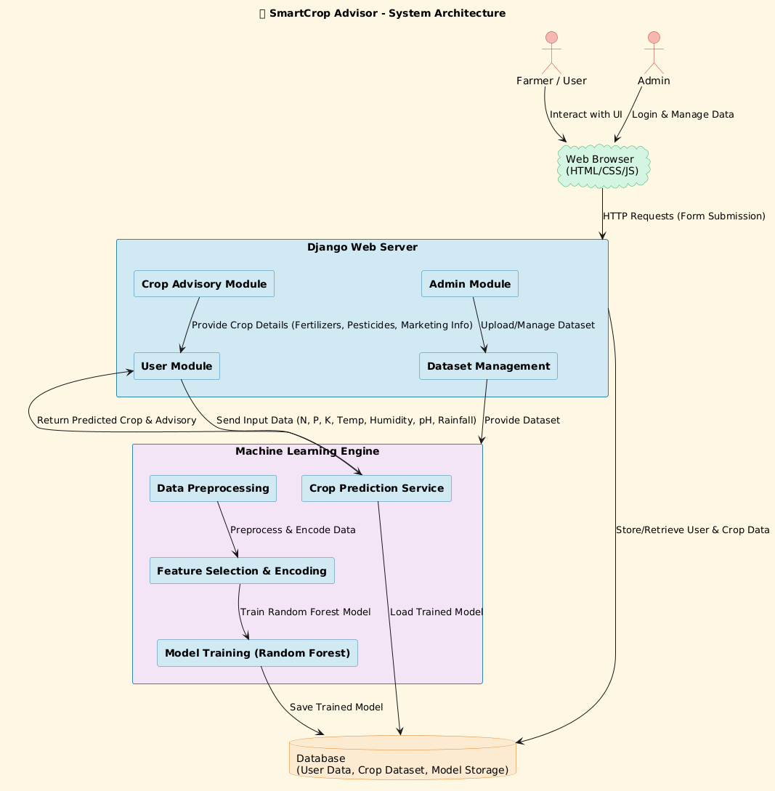

System Architecture

# **SYSTEM REQUIREMENTS**

**H/W SYSTEM CONFIGURATION:**

* **Processor - Pentium –IV**
* **RAM - 4 GB (min)**
* **Hard Disk - 20 GB**
* **Key Board - Standard Windows Keyboard**
* **Mouse - Two or Three Button Mouse**
* **Monitor - SVGA**

**SOFTWARE REQUIREMENTS:**

* **Operating system : Windows 7 Ultimate.**
* **Coding Language : Python.**
* **Back-End : Django-ORM**
* **Designing : Html, css, javascript.**
* **Data Base : MySQL / (WAMP Server).**

# **SYSTEM STUDY**

**FEASIBILITY STUDY**

The feasibility of the project is analyzed in this phase and business proposal is put forth with a very general plan for the project and some cost estimates. During system analysis the feasibility study of the proposed system is to be carried out. This is to ensure that the proposed system is not a burden to the company. For feasibility analysis, some understanding of the major requirements for the system is essential.

Three key considerations involved in the feasibility analysis are

* ECONOMICAL FEASIBILITY
* TECHNICAL FEASIBILITY
* SOCIAL FEASIBILITY

**ECONOMICAL FEASIBILITY**

This study is carried out to check the economic impact that the system will have on the organization. The amount of fund that the company can pour into the research and development of the system is limited. The expenditures must be justified. Thus the developed system as well within the budget and this was achieved because most of the technologies used are freely available. Only the customized products had to be purchased.

**TECHNICAL FEASIBILITY**

This study is carried out to check the technical feasibility, that is, the technical requirements of the system. Any system developed must not have a high demand on the available technical resources. This will lead to high demands on the available technical resources. This will lead to high demands being placed on the client. The developed system must have a modest requirement, as only minimal or null changes are required for implementing this system.

**SOCIAL FEASIBILITY**

The aspect of study is to check the level of acceptance of the system by the user. This includes the process of training the user to use the system efficiently. The user must not feel threatened by the system, instead must accept it as a necessity. The level of acceptance by the users solely depends on the methods that are employed to educate the user about the system and to make him familiar with it. His level of confidence must be raised so that he is also able to make some constructive criticism, which is welcomed, as he is the final user of the system.

# **SYSTEM DESIGN**

**UML DIAGRAMS**

UML stands for Unified Modeling Language. UML is a standardized general-purpose modeling language in the field of object-oriented software engineering. The standard is managed, and was created by, the Object Management Group. The goal is for UML to become a common language for creating models of object-oriented computer software. In its current form UML is comprised of two major components: a Meta-model and a notation. In the future, some form of method or process may also be added to; or associated with, UML.

The Unified Modeling Language is a standard language for specifying, Visualization, Constructing and documenting the artifacts of software system, as well as for business modeling and other non-software systems. The UML represents a collection of best engineering practices that have proven successful in the modeling of large and complex systems. The UML is a very important part of developing objects-oriented software and the software development process. The UML uses mostly graphical notations to express the design of software projects.

**GOALS:** The Primary goals in the design of the UML are as follows:

* Provide users a ready-to-use, expressive visual modeling Language so that they can develop and exchange meaningful models.
* Provide extendibility and specialization mechanisms to extend the core concepts.
* Be independent of particular programming languages and development process.
* Provide a formal basis for understanding the modeling language.
* Encourage the growth of OO tools market.
* Support higher level development concepts such as collaborations, frameworks, patterns and components.
* Integrate best practices.

**Class diagram**

The class diagram is used to refine the use case diagram and define a detailed design of the system. The class diagram classifies the actors defined in the use case diagram into a set of interrelated classes. The relationship or association between the classes can be either an "is-a" or "has-a" relationship. Each class in the class diagram was capable of providing certain functionalities. These functionalities provided by the class are termed "methods" of the class. Apart from this, each class may have certain "attributes" that uniquely identify the class.

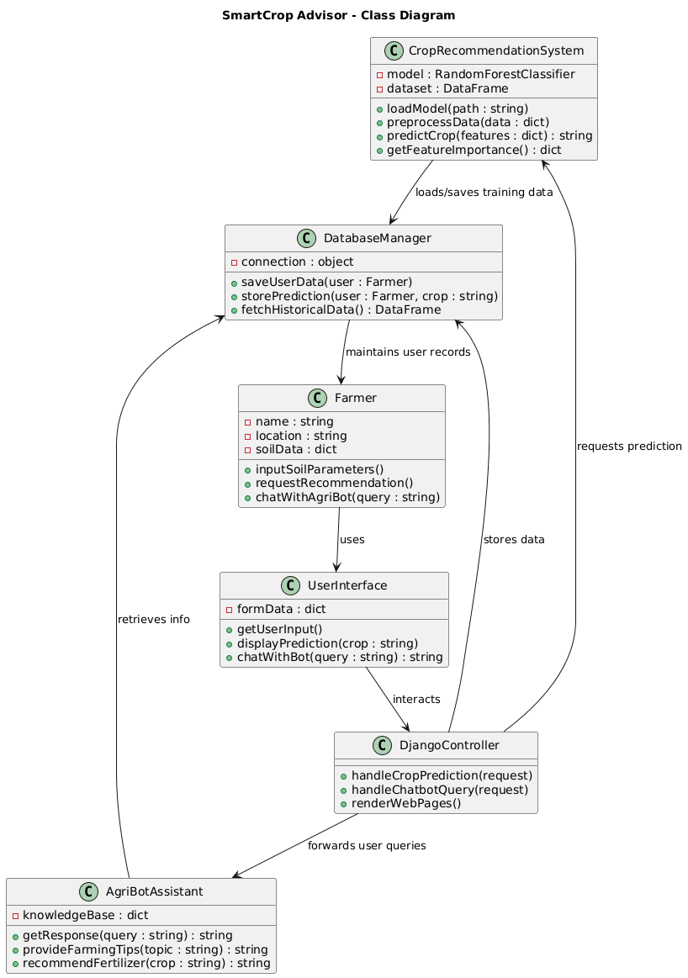

Figure-5.1: Class Diagram

**Sequence Diagram**

A sequence diagram in Unified Modeling Language (UML) is a kind of interaction diagram that shows how processes operate with one another and in what order. It is a construct of a Message Sequence Chart. A sequence diagram shows, as parallel vertical lines (“lifelines”), different processes or objects that live simultaneously, and as horizontal arrows, the messages exchanged between them, in the order in which they occur. This allows the specification of simple runtime scenarios in a graphical manner.

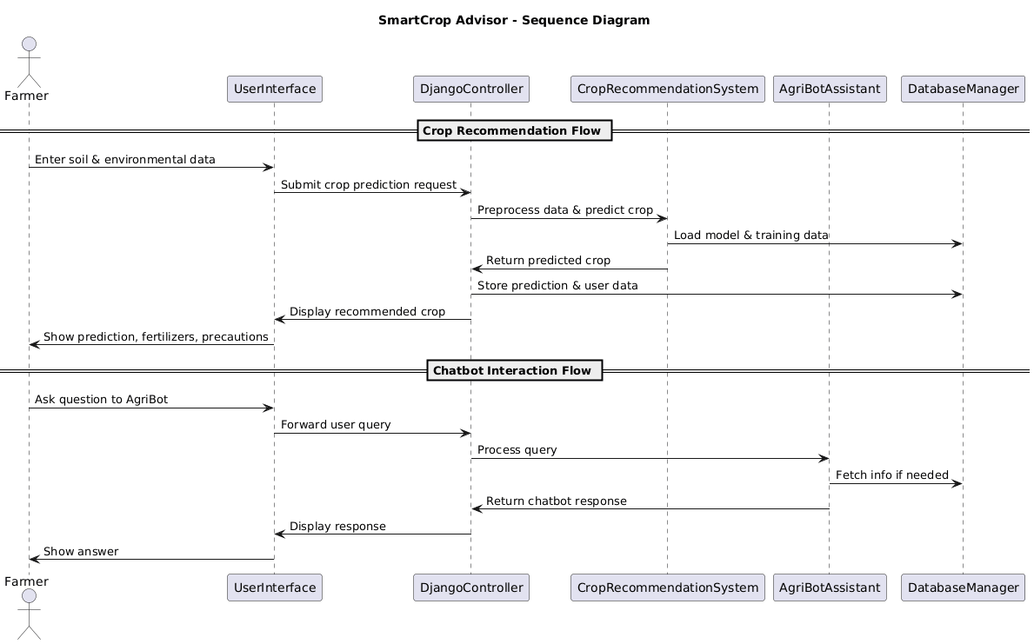

Figure-5.2: Sequence Diagram

**Activity diagram**

Activity diagrams are graphical representations of Workflows of stepwise activities and actions with support for choice, iteration, and concurrency. In the Unified Modeling Language, activity diagrams can be used to describe the business and operational step-by-step workflows of components in a system. An activity diagram shows the overall flow of control.

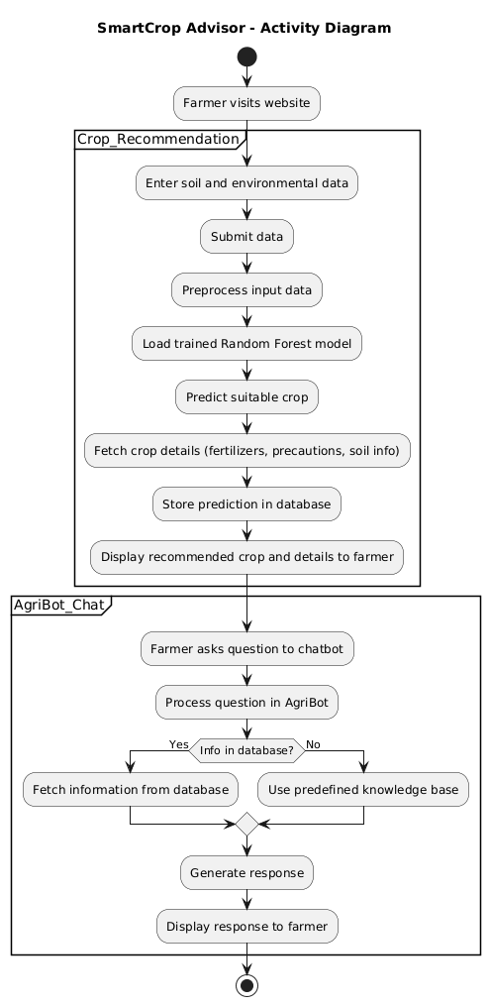

Figure-5.3: Activity Diagram

**Data flow diagram**

A data flow diagram (DFD) is a graphical representation of how data moves within an information system. It is a modeling technique used in system analysis and design to illustrate the flow of data between various processes, data stores, data sources, and data destinations within a system or between systems. Data flow diagrams are often used to depict the structure and behavior of a system, emphasizing the flow of data and the transformations it undergoes as it moves through the system.

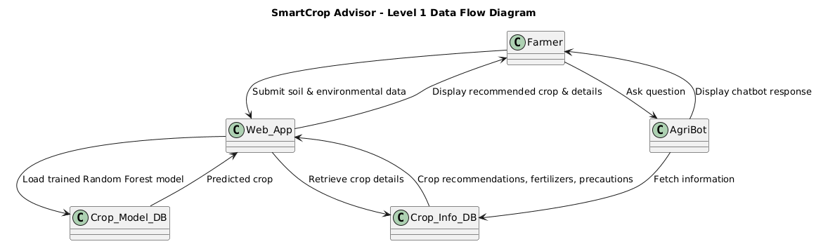

Figure-5.4: Dataflow Diagram

**Component diagram:** Component diagram describes the organization and wiring of the physical components in a system.

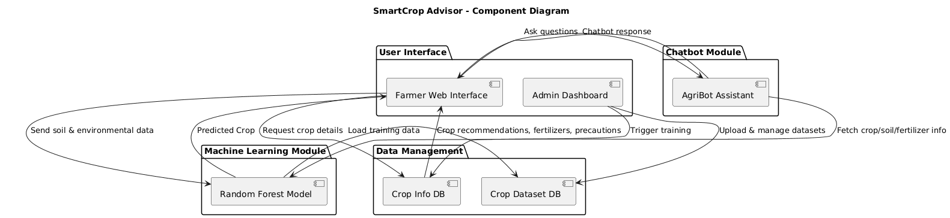

Figure-5.5: Component Diagram

**Use Case diagram:** A use case diagram in the Unified Modeling Language (UML) is a type of behavioral diagram defined by and created from a Use-case analysis. Its purpose is to present a graphical overview of the functionality provided by a system in terms of actors, their goals (represented as use cases), and any dependencies between those use cases. The main purpose of a use case diagram is to show what system functions are performed for which actor. Roles of the actors in the system can be depicted.

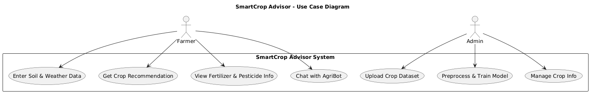

Figure-5.6: Use Case Diagram

**Deployment Diagram:**

A deployment diagram in UML illustrates the physical arrangement of hardware and software components in the system. It visualizes how different software artifacts, such as data processing scripts and model training components, are deployed across hardware nodes and interact with each other, providing insight into the system’s infrastructure and deployment strategy.

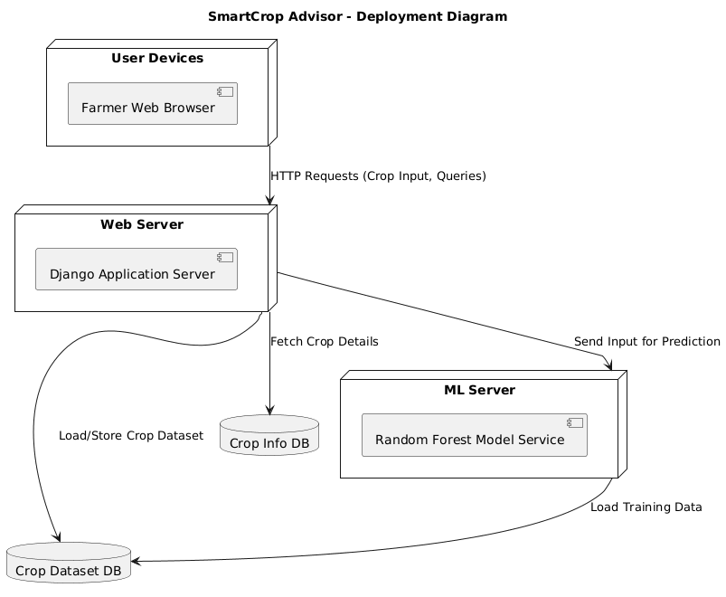

Figure-5.7: DeploymentDiagram

**Architectural Block Diagram**

An architectural block diagram offers a high-level view of a system’s structure, showcasing the main components and their interactions. It represents how major modules, such as data sources, processing units, and evaluation components, are organized and how they communicate with each other to accomplish the system’s objectives. This diagram helps in understanding the overall design and flow of the system.

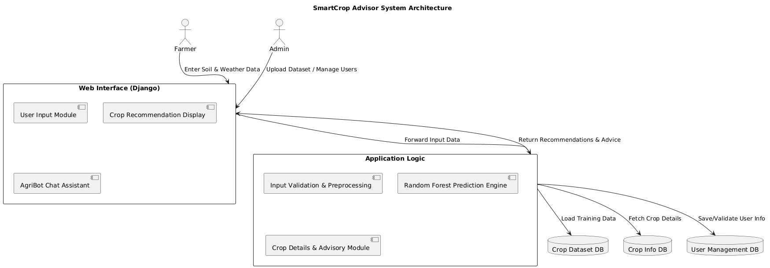

Figure 5.8: Architectural Block Diagram

# **SOFTWARE ENVIRONMENT**

**What is Python :-**

Below are some facts about Python.

Python is currently the most widely used multi-purpose, high-level programming language.

Python allows programming in Object-Oriented and Procedural paradigms. Python programs generally are smaller than other programming languages like Java.

Programmers have to type relatively less and indentation requirement of the language, makes them readable all the time.

Python language is being used by almost all tech-giant companies like – Google, Amazon, Facebook, Instagram, Dropbox, Uber… etc.

The biggest strength of Python is huge collection of standard library which can be used for the following –

* + [Machine Learning](https://www.geeksforgeeks.org/machine-learning/)
  + GUI Applications (like Kivy, Tkinter, PyQt etc. )
  + Web frameworks like Django (used by YouTube, Instagram, Dropbox)
  + Image processing (like Opencv, Pillow)
  + Web scraping (like Scrapy, BeautifulSoup, Selenium)
  + Test frameworks
  + Multimedia

**Advantages of Python :-**

Let’s see how Python dominates over other languages.

**1. Extensive Libraries**

Python downloads with an extensive library and it *contain code for various purposes like regular expressions, documentation-generation, unit-testing, web browsers, threading, databases, CGI, email, image manipulation, and more.* So, we don’t have to write the complete code for that manually.

**2. Extensible**

As we have seen earlier, Python can be extended to other languages. You can write some of your code in languages like C++ or C. This comes in handy, especially in projects.

**3. Embeddable**

Complimentary to extensibility, Python is embeddable as well. You can put your Python code in your source code of a different language, like C++. This lets us add scripting capabilities to our code in the other language.

**4. Improved Productivity**

The language’s simplicity and extensive libraries render programmers more productive than languages like Java and C++ do. Also, the fact that you need to write less and get more things done.

**5. IOT Opportunities**

Since Python forms the basis of new platforms like Raspberry Pi, it finds the future bright for the Internet Of Things. This is a way to connect the language with the real world.

**6. Simple and Easy**

When working with Java, you may have to create a class to print ‘Hello World’. But in Python, just a print statement will do. It is also quite easy to learn, understand, and code. This is why when people pick up Python, they have a hard time adjusting to other more verbose languages like Java.

**7. Readable**

Because it is not such a verbose language, reading Python is much like reading English. This is the reason why it is so easy to learn, understand, and code. It also does not need curly braces to define blocks, and indentation is mandatory. This further aids the readability of the code.

**8. Object-Oriented**

This language supports both the procedural and object-oriented programming paradigms. While functions help us with code reusability, classes and objects let us model the real world. A class allows the encapsulation of data and functions into one.

**9. Free and Open-Source**

Like we said earlier, Python is freely available. But not only can you [download Python](https://data-flair.training/blogs/install-python-windows/) for free, but you can also download its source code, make changes to it, and even distribute it. It downloads with an extensive collection of libraries to help you with your tasks.

**10. Portable**

When you code your project in a language like C++, you may need to make some changes to it if you want to run it on another platform. But it isn’t the same with Python. Here, you need to code only once, and you can run it anywhere. This is called Write Once Run Anywhere (WORA). However, you need to be careful enough not to include any system-dependent features**.**

**11. Interpreted**

Lastly, we will say that it is an interpreted language. Since statements are executed one by one, debugging is easier than in compiled languages.

*Any doubts till now in the advantages of Python? Mention in the comment section.*

**Advantages of Python Over Other Languages**

**1. Less Coding**

Almost all of the tasks done in Python requires less coding when the same task is done in other languages. Python also has an awesome standard library support, so you don’t have to search for any third-party libraries to get your job done. This is the reason that many people suggest learning Python to beginners.

**2. Affordable**

Python is free therefore individuals, small companies or big organizations can leverage the free available resources to build applications. Python is popular and widely used so it gives you better community support.

The 2019 Github annual survey showed us that Python has overtaken Java in the most popular programming language category.

**3. Python is for Everyone**

Python code can run on any machine whether it is Linux, Mac or Windows. Programmers need to learn different languages for different jobs but with Python, you can professionally build web apps, perform data analysis and [machine learning](https://data-flair.training/blogs/machine-learning-tutorials-home/), automate things,do web scraping and also build games and powerful visualizations. It is an all-rounder programming language.

**Disadvantages of Python**

So far, we’ve seen why Python is a great choice for your project. But if you choose it, you should be aware of its consequences as well. Let’s now see the downsides of choosing Python over another language.

**1. Speed Limitations**

We have seen that Python code is executed line by line. But since [Python](https://www.python.org/) is interpreted, it often results in slow execution. This, however, isn’t a problem unless speed is a focal point for the project. In other words, unless high speed is a requirement, the benefits offered by Python are enough to distract us from its speed limitations.

**2. Weak in Mobile Computing and Browsers**

While it serves as an excellent server-side language, Python is much rarely seen on the client-side. Besides that, it is rarely ever used to implement smartphone-based applications. One such application is called Carbonnelle.

The reason it is not so famous despite the existence of Brython is that it isn’t that secure.

**3. Design Restrictions**

As you know, Python is dynamically-typed. This means that you don’t need to declare the type of variable while writing the code. It uses duck-typing. But wait, what’s that? Well, it just means that if it looks like a duck, it must be a duck. While this is easy on the programmers during coding, it can raise run-time errors.

**4. Underdeveloped Database Access Layers**

Compared to more widely used technologies like JDBC (Java DataBase Connectivity) and ODBC (Open DataBase Connectivity), Python’s database access layers are a bit underdeveloped. Consequently, it is less often applied in huge enterprises.

**5. Simple**

No, we’re not kidding. Python’s simplicity can indeed be a problem. Take my example. I don’t do Java, I’m more of a Python person. To me, its syntax is so simple that the verbosity of Java code seems unnecessary.

This was all about the Advantages and Disadvantages of Python Programming Language.

**History of Python : -**

What do the alphabet and the programming language Python have in common? Right, both start with ABC. If we are talking about ABC in the Python context, it's clear that the programming language ABC is meant. ABC is a general-purpose programming language and programming environment, which had been developed in the Netherlands, Amsterdam, at the CWI (Centrum Wiskunde &Informatica). The greatest achievement of ABC was to influence the design of Python.Python was conceptualized in the late 1980s. Guido van Rossum worked that time in a project at the CWI, called Amoeba, a distributed operating system. In an interview with Bill Venners1, Guido van Rossum said: "In the early 1980s, I worked as an implementer on a team building a language called ABC at Centrum voor Wiskunde en Informatica (CWI). I don't know how well people know ABC's influence on Python. I try to mention ABC's influence because I'm indebted to everything I learned during that project and to the people who worked on it."Later on in the same Interview, Guido van Rossum continued: "I remembered all my experience and some of my frustration with ABC. I decided to try to design a simple scripting language that possessed some of ABC's better properties, but without its problems. So I started typing. I created a simple virtual machine, a simple parser, and a simple runtime. I made my own version of the various ABC parts that I liked. I created a basic syntax, used indentation for statement grouping instead of curly braces or begin-end blocks, and developed a small number of powerful data types: a hash table (or dictionary, as we call it), a list, strings, and numbers."

**Modules Used in Project**

**TensorFlow**

TensorFlow is a free and open-source software library for dataflow and differentiable programming across a range of tasks. It is a symbolic math library and is also used for machine learning applications such as neural networks. It is used for both research and production at Google.‍

TensorFlow was developed by the Google Brain team for internal Google use. It was released under the Apache 2.0 open-source license on November 9, 2015.

**NumPy**

NumPy is a general-purpose array-processing package. It provides a high-performance multidimensional array object, and tools for working with these arrays.

It is the fundamental package for scientific computing with Python. It contains various features including these important ones:

* A powerful N-dimensional array object
* Sophisticated (broadcasting) functions
* Tools for integrating C/C++ and Fortran code
* Useful linear algebra, Fourier transform, and random number capabilities

Besides its obvious scientific uses, NumPy can also be used as an efficient multi-dimensional container of generic data. Arbitrary datatypes can be defined using NumPy which allows NumPy to seamlessly and speedily integrate with a wide variety of databases.

**Pandas**

Pandas is an open-source Python Library providing high-performance data manipulation and analysis tool using its powerful data structures. Python was majorly used for data munging and preparation. It had very little contribution towards data analysis. Pandas solved this problem. Using Pandas, we can accomplish five typical steps in the processing and analysis of data, regardless of the origin of data load, prepare, manipulate, model, and analyze. Python with Pandas is used in a wide range of fields including academic and commercial domains including finance, economics, Statistics, analytics, etc.

**Matplotlib**

Matplotlib is a Python 2D plotting library which produces publication quality figures in a variety of hardcopy formats and interactive environments across platforms. Matplotlib can be used in Python scripts, the Python and IPython shells, the Jupyter Notebook, web application servers, and four graphical user interface toolkits. Matplotlib tries to make easy things easy and hard things possible. You can generate plots, histograms, power spectra, bar charts, error charts, scatter plots, etc., with just a few lines of code. For examples, see the sample plots and thumbnail gallery.

For simple plotting the pyplot module provides a MATLAB-like interface, particularly when combined with IPython. For the power user, you have full control of line styles, font properties, axes properties, etc, via an object-oriented interface or via a set of functions familiar to MATLAB users.

**Scikit – learn**

Scikit-learn provides a range of supervised and unsupervised learning algorithms via a consistent interface in Python. It is licensed under a permissive simplified BSD license and is distributed under many Linux distributions, encouraging academic and commercial use. Python

Python is an interpreted high-level programming language for general-purpose programming. Created by Guido van Rossum and first released in 1991, Python has a design philosophy that emphasizes code readability, notably using significant whitespace.

Python features a dynamic type system and automatic memory management. It supports multiple programming paradigms, including object-oriented, imperative, functional and procedural, and has a large and comprehensive standard library.

* Python is Interpreted − Python is processed at runtime by the interpreter. You do not need to compile your program before executing it. This is similar to PERL and PHP.
* Python is Interactive − you can actually sit at a Python prompt and interact with the interpreter directly to write your programs.

Python also acknowledges that speed of development is important. Readable and terse code is part of this, and so is access to powerful constructs that avoid tedious repetition of code. Maintainability also ties into this may be an all but useless metric, but it does say something about how much code you have to scan, read and/or understand to troubleshoot problems or tweak behaviors. This speed of development, the ease with which a programmer of other languages can pick up basic Python skills and the huge standard library is key to another area where Python excels. All its tools have been quick to implement, saved a lot of time, and several of them have later been patched and updated by people with no Python background - without breaking.

**Install Python Step-by-Step in Windows and Mac**

Python a versatile programming language doesn’t come pre-installed on your computer devices. Python was first released in the year 1991 and until today it is a very popular high-level programming language. Its style philosophy emphasizes code readability with its notable use of great whitespace.

The object-oriented approach and language construct provided by Python enables programmers to write both clear and logical code for projects. This software does not come pre-packaged with Windows.

**How to Install Python on Windows and Mac**

There have been several updates in the Python version over the years. The question is how to install Python? It might be confusing for the beginner who is willing to start learning Python but this tutorial will solve your query. The latest or the newest version of Python is version 3.7.4 or in other words, it is Python 3.

Note: The python version 3.7.4 cannot be used on Windows XP or earlier devices.

Before you start with the installation process of Python. First, you need to know about your System Requirements. Based on your system type i.e., operating system and based processor, you must download the python version. My system type is a Windows 64-bit operating system. So, the steps below are to install python version 3.7.4 on Windows 7 device or to install Python 3. Download the Python Cheatsheet here. The steps on how to install Python on Windows 10, 8 and 7 are divided into 4 parts to help understand better.

**Download the Correct version into the system**

Step 1: Go to the official site to download and install python using Google Chrome or any other web browser. OR Click on the following link: https://www.python.org

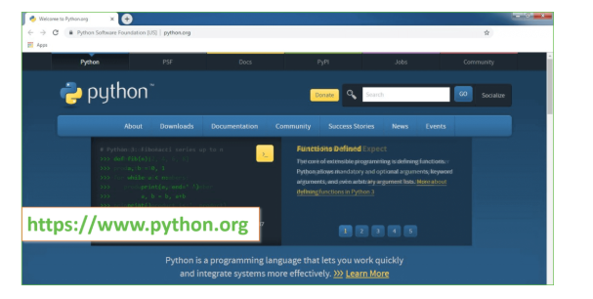

Now, check for the latest and the correct version for your operating system.

Step 2: Click on the Download Tab.

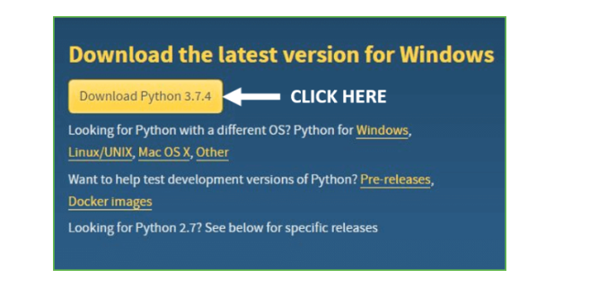

Step 3: You can either select the Download Python for windows 3.7.4 button in Yellow Color or you can scroll further down and click on download with respective to their version. Here, we are downloading the most recent python version for windows 3.7.4

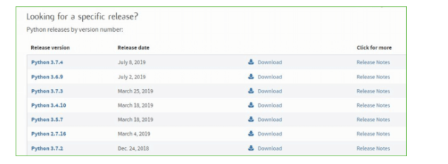

Step 4: Scroll down the page until you find the Files option.

Step 5: Here you see a different version of python along with the operating system.

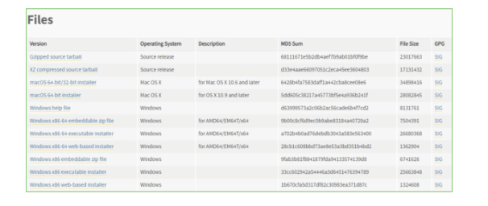

* To download Windows 32-bit python, you can select any one from the three options: Windows x86 embeddable zip file, Windows x86 executable installer or Windows x86 web-based installer.
* To download Windows 64-bit python, you can select any one from the three options: Windows x86-64 embeddable zip file, Windows x86-64 executable installer or Windows x86-64 web-based installer.

Here we will install Windows x86-64 web-based installer. Here your first part regarding which version of python is to be downloaded is completed. Now we move ahead with the second part in installing python i.e., Installation

Note: To know the changes or updates that are made in the version you can click on the Release Note Option.

Installation of Python

Step 1: Go to Download and Open the downloaded python version to carry out the installation process.

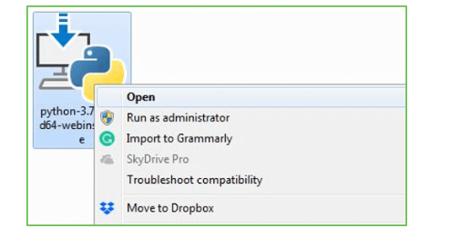

Step 2: Before you click on Install Now, make sure to put a tick on Add Python 3.7 to PATH.

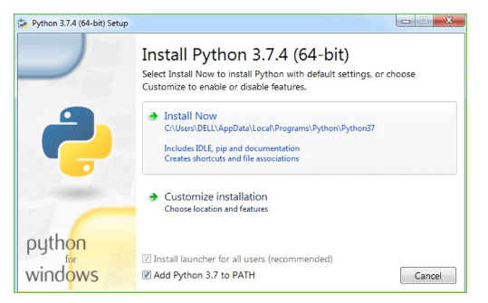

Step 3: Click on Install NOW After the installation is successful. Click on Close.

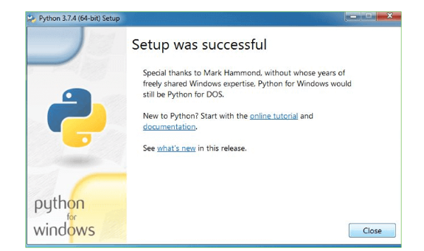

With these above three steps on python installation, you have successfully and correctly installed Python. Now is the time to verify the installation.

Note: The installation process might take a couple of minutes.

Verify the Python Installation

Step 1: Click on Start

Step 2: In the Windows Run Command, type “cmd”.

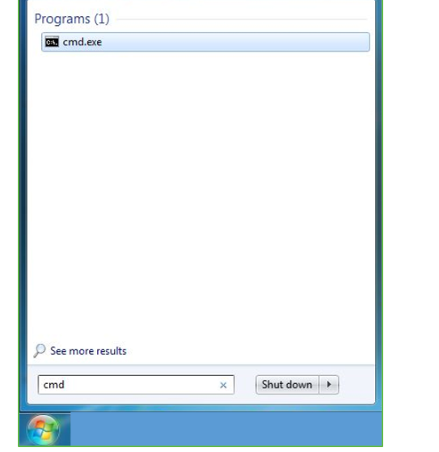

Step 3: Open the Command prompt option.

Step 4: Let us test whether the python is correctly installed. Type python –V and press Enter.

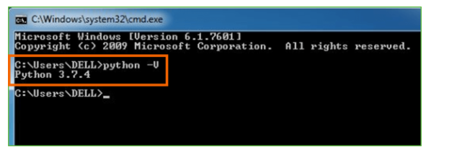

Step 5: You will get the answer as 3.7.4

Note: If you have any of the earlier versions of Python already installed. You must first uninstall the earlier version and then install the new one.

Check how the Python IDLE works

Step 1: Click on Start

Step 2: In the Windows Run command, type “python idle”.

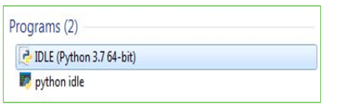

Step 3: Click on IDLE (Python 3.7 64-bit) and launch the program

Step 4: To go ahead with working in IDLE you must first save the file. Click on File > Click on Save

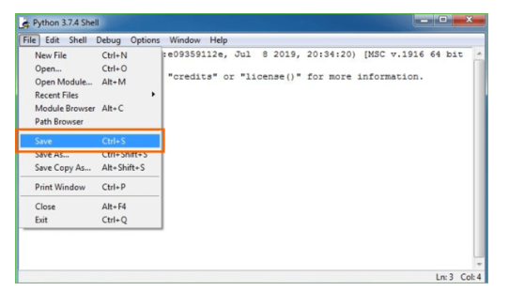

Step 5: Name the file and save as type should be Python files. Click on SAVE. Here I have named the files as Hey World.

Step 6: Now for e.g., enter print (“Hey World”) and Press Enter.

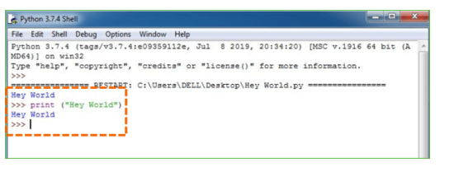

You will see that the command given is launched. With this, we end our tutorial on how to install Python. You have learned how to download python for windows into your respective operating system.

Note: Unlike Java, Python does not need semicolons at the end of the statements otherwise it won’t work.

**What is Machine Learning : -**

Before we take a look at the details of various machine learning methods, let's start by looking at what machine learning is, and what it isn't. Machine learning is often categorized as a subfield of artificial intelligence, but I find that categorization can often be misleading at first brush. The study of machine learning certainly arose from research in this context, but in the data science application of machine learning methods, it's more helpful to think of machine learning as a means of *building models of data*.

Fundamentally, machine learning involves building mathematical models to help understand data. "Learning" enters the fray when we give these models *tunable parameters* that can be adapted to observed data; in this way the program can be considered to be "learning" from the data. Once these models have been fit to previously seen data, they can be used to predict and understand aspects of newly observed data. I'll leave to the reader the more philosophical digression regarding the extent to which this type of mathematical, model-based "learning" is similar to the "learning" exhibited by the human brain. Understanding the problem setting in machine learning is essential to using these tools effectively, and so we will start with some broad categorizations of the types of approaches we'll discuss here.

**Categories Of Machine Leaning :-**

At the most fundamental level, machine learning can be categorized into two main types: supervised learning and unsupervised learning.

*Supervised learning* involves somehow modeling the relationship between measured features of data and some label associated with the data; once this model is determined, it can be used to apply labels to new, unknown data. This is further subdivided into *classification* tasks and *regression* tasks: in classification, the labels are discrete categories, while in regression, the labels are continuous quantities. We will see examples of both types of supervised learning in the following section.

*Unsupervised learning* involves modeling the features of a dataset without reference to any label, and is often described as "letting the dataset speak for itself." These models include tasks such as *clustering* and *dimensionality reduction.* Clustering algorithms identify distinct groups of data, while dimensionality reduction algorithms search for more succinct representations of the data. We will see examples of both types of unsupervised learning in the following section.

**Need for Machine Learning**

Human beings, at this moment, are the most intelligent and advanced species on earth because they can think, evaluate and solve complex problems. On the other side, AI is still in its initial stage and haven’t surpassed human intelligence in many aspects. Then the question is that what is the need to make machine learn? The most suitable reason for doing this is, “to make decisions, based on data, with efficiency and scale”.

Lately, organizations are investing heavily in newer technologies like Artificial Intelligence, Machine Learning and Deep Learning to get the key information from data to perform several real-world tasks and solve problems. We can call it data-driven decisions taken by machines, particularly to automate the process. These data-driven decisions can be used, instead of using programing logic, in the problems that cannot be programmed inherently. The fact is that we can’t do without human intelligence, but other aspect is that we all need to solve real-world problems with efficiency at a huge scale. That is why the need for machine learning arises.

**Challenges in Machines Learning :-**

While Machine Learning is rapidly evolving, making significant strides with cybersecurity and autonomous cars, this segment of AI as whole still has a long way to go. The reason behind is that ML has not been able to overcome number of challenges. The challenges that ML is facing currently are −

Quality of data − Having good-quality data for ML algorithms is one of the biggest challenges. Use of low-quality data leads to the problems related to data preprocessing and feature extraction.

Time-Consuming task − Another challenge faced by ML models is the consumption of time especially for data acquisition, feature extraction and retrieval.

Lack of specialist persons − As ML technology is still in its infancy stage, availability of expert resources is a tough job.

No clear objective for formulating business problems − Having no clear objective and well-defined goal for business problems is another key challenge for ML because this technology is not that mature yet.

Issue of overfitting & underfitting − If the model is overfitting or underfitting, it cannot be represented well for the problem.

Curse of dimensionality − Another challenge ML model faces is too many features of data points. This can be a real hindrance.

Difficulty in deployment − Complexity of the ML model makes it quite difficult to be deployed in real life.

**Applications of Machines Learning :-**

Machine Learning is the most rapidly growing technology and according to researchers we are in the golden year of AI and ML. It is used to solve many real-world complex problems which cannot be solved with traditional approach. Following are some real-world applications of ML −

* Emotion analysis
* Sentiment analysis
* Error detection and prevention
* Weather forecasting and prediction
* Stock market analysis and forecasting
* Speech synthesis
* Speech recognition
* Customer segmentation
* Object recognition
* Fraud detection
* Fraud prevention
* Recommendation of products to customer in online shopping

**How to Start Learning Machine Learning?**

Arthur Samuel coined the term “Machine Learning” in 1959 and defined it as a “Field of study that gives computers the capability to learn without being explicitly programmed”.

And that was the beginning of Machine Learning! In modern times, Machine Learning is one of the most popular (if not the most!) career choices. According to [Indeed](http://blog.indeed.com/2019/03/14/best-jobs-2019/), Machine Learning Engineer Is The Best Job of 2019 with a *344%* growth and an average base salary of $146,085 per year.

But there is still a lot of doubt about what exactly is Machine Learning and how to start learning it? So this article deals with the Basics of Machine Learning and also the path you can follow to eventually become a full-fledged Machine Learning Engineer. Now let’s get started!!!

**How to start learning ML?**

This is a rough roadmap you can follow on your way to becoming an insanely talented Machine Learning Engineer. Of course, you can always modify the steps according to your needs to reach your desired end-goal!

**Step 1 – Understand the Prerequisites**

In case you are a genius, you could start ML directly but normally, there are some prerequisites that you need to know which include Linear Algebra, Multivariate Calculus, Statistics, and Python. And if you don’t know these, never fear! You don’t need a Ph.D. degree in these topics to get started but you do need a basic understanding.

**(a) Learn Linear Algebra and Multivariate Calculus**

Both Linear Algebra and Multivariate Calculus are important in Machine Learning. However, the extent to which you need them depends on your role as a data scientist. If you are more focused on application heavy machine learning, then you will not be that heavily focused on maths as there are many common libraries available. But if you want to focus on R&D in Machine Learning, then mastery of Linear Algebra and Multivariate Calculus is veryimportant as you will have to implement many ML algorithms from scratch.

**(b) Learn Statistics**

Data plays a huge role in Machine Learning. In fact, around 80% of your time as an ML expert will be spent collecting and cleaning data. And statistics is a field that handles the collection, analysis, and presentation of data. So it is no surprise that you need to learn it!!!  
Some of the key concepts in statistics that are important are Statistical Significance, Probability Distributions, Hypothesis Testing, Regression, etc. Also, Bayesian Thinking is also a very important part of ML which deals with various concepts like Conditional Probability, Priors, and Posteriors, Maximum Likelihood, etc.

**(c) Learn Python**

Some people prefer to skip Linear Algebra, Multivariate Calculus and Statistics and learn them as they go along with trial and error. But the one thing that you absolutely cannot skip is [Python](https://www.geeksforgeeks.org/python-programming-language/)! While there are other languages you can use for Machine Learning like R, Scala, etc. Python is currently the most popular language for ML. In fact, there are many Python libraries that are specifically useful for Artificial Intelligence and Machine Learning such as [Keras](https://keras.io/), [TensorFlow](https://www.tensorflow.org/), [Scikit-learn](https://scikit-learn.org/stable/), etc.

So if you want to learn ML, it’s best if you learn Python! You can do that using various online resources and courses such as [Fork Python](https://practice.geeksforgeeks.org/courses/fork-python) available Free on GeeksforGeeks.

**Step 2 – Learn Various ML Concepts**

Now that you are done with the prerequisites, you can move on to actually learning ML (Which is the fun part!!!) It’s best to start with the basics and then move on to the more complicated stuff. Some of the basic concepts in ML are:

**(a) Terminologies of Machine Learning**

* Model – A model is a specific representation learned from data by applying some machine learning algorithm. A model is also called a hypothesis.
* Feature – A feature is an individual measurable property of the data. A set of numeric features can be conveniently described by a feature vector. Feature vectors are fed as input to the model. For example, in order to predict a fruit, there may be features like color, smell, taste, etc.
* Target (Label) – A target variable or label is the value to be predicted by our model. For the fruit example discussed in the feature section, the label with each set of input would be the name of the fruit like apple, orange, banana, etc.
* Training – The idea is to give a set of inputs(features) and it’s expected outputs(labels), so after training, we will have a model (hypothesis) that will then map new data to one of the categories trained on.
* Prediction – Once our model is ready, it can be fed a set of inputs to which it will provide a predicted output(label).

**(b) Types of Machine Learning**

* Supervised Learning – This involves learning from a training dataset with labeled data using classification and regression models. This learning process continues until the required level of performance is achieved.
* Unsupervised Learning – This involves using unlabelled data and then finding the underlying structure in the data in order to learn more and more about the data itself using factor and cluster analysis models.
* Semi-supervised Learning – This involves using unlabelled data like Unsupervised Learning with a small amount of labeled data. Using labeled data vastly increases the learning accuracy and is also more cost-effective than Supervised Learning.
* Reinforcement Learning – This involves learning optimal actions through trial and error. So the next action is decided by learning behaviors that are based on the current state and that will maximize the reward in the future.

**Advantages of Machine learning :-**

**1. Easily identifies trends and patterns -**

Machine Learning can review large volumes of data and discover specific trends and patterns that would not be apparent to humans. For instance, for an e-commerce website like Amazon, it serves to understand the browsing behaviors and purchase histories of its users to help cater to the right products, deals, and reminders relevant to them. It uses the results to reveal relevant advertisements to them.

**2. No human intervention needed (automation)**

With ML, you don’t need to babysit your project every step of the way. Since it means giving machines the ability to learn, it lets them make predictions and also improve the algorithms on their own. A common example of this is anti-virus softwares; they learn to filter new threats as they are recognized. ML is also good at recognizing spam.

**3. Continuous Improvement**

As [ML algorithms](https://data-flair.training/blogs/machine-learning-algorithms/) gain experience, they keep improving in accuracy and efficiency. This lets them make better decisions. Say you need to make a weather forecast model. As the amount of data you have keeps growing, your algorithms learn to make more accurate predictions faster.

**4. Handling multi-dimensional and multi-variety data**

Machine Learning algorithms are good at handling data that are multi-dimensional and multi-variety, and they can do this in dynamic or uncertain environments.

**5. Wide Applications**

You could be an e-tailer or a healthcare provider and make ML work for you. Where it does apply, it holds the capability to help deliver a much more personal experience to customers while also targeting the right customers.

**Disadvantages of Machine Learning :-**

**1. Data Acquisition**

Machine Learning requires massive data sets to train on, and these should be inclusive/unbiased, and of good quality. There can also be times where they must wait for new data to be generated**.**

**2. Time and Resources**

ML needs enough time to let the algorithms learn and develop enough to fulfill their purpose with a considerable amount of accuracy and relevancy. It also needs massive resources to function. This can mean additional requirements of computer power for you.

**3. Interpretation of Results**

Another major challenge is the ability to accurately interpret results generated by the algorithms. You must also carefully choose the algorithms for your purpose.

**4. High error-susceptibility**

[Machine Learning](https://en.wikipedia.org/wiki/Machine_learning) is autonomous but highly susceptible to errors. Suppose you train an algorithm with data sets small enough to not be inclusive. You end up with biased predictions coming from a biased training set. This leads to irrelevant advertisements being displayed to customers. In the case of ML, such blunders can set off a chain of errors that can go undetected for long periods of time. And when they do get noticed, it takes quite some time to recognize the source of the issue, and even longer to correct it.

# **SYSTEM TEST**

The purpose of testing is to discover errors. Testing is the process of trying to discover every conceivable fault or weakness in a work product. It provides a way to check the functionality of components, sub assemblies, assemblies and/or a finished product It is the process of exercising software with the intent of ensuring that the Software system meets its requirements and user expectations and does not fail in an unacceptable manner. There are various types of test. Each test type addresses a specific testing requirement.

**TYPES OF TESTS**

**Unit testing**

Unit testing involves the design of test cases that validate that the internal program logic is functioning properly, and that program inputs produce valid outputs. All decision branches and internal code flow should be validated. It is the testing of individual software units of the application .it is done after the completion of an individual unit before integration. This is a structural testing, that relies on knowledge of its construction and is invasive. Unit tests perform basic tests at component level and test a specific business process, application, and/or system configuration. Unit tests ensure that each unique path of a business process performs accurately to the documented specifications and contains clearly defined inputs and expected results.

**Integration testing**

Integration tests are designed to test integrated software components to determine if they actually run as one program. Testing is event driven and is more concerned with the basic outcome of screens or fields. Integration tests demonstrate that although the components were individually satisfaction, as shown by successfully unit testing, the combination of components is correct and consistent. Integration testing is specifically aimed at exposing the problems that arise from the combination of components.

**Functional test**

Functional tests provide systematic demonstrations that functions tested are available as specified by the business and technical requirements, system documentation, and user manuals.

Functional testing is centered on the following items:

Valid Input : identified classes of valid input must be accepted.

Invalid Input : identified classes of invalid input must be rejected.

Functions : identified functions must be exercised.

Output : identified classes of application outputs must be exercised.

Systems/Procedures : interfacing systems or procedures must be invoked.

Organization and preparation of functional tests is focused on requirements, key functions, or special test cases. In addition, systematic coverage pertaining to identify Business process flows; data fields, predefined processes, and successive processes must be considered for testing. Before functional testing is complete, additional tests are identified and the effective value of current tests is determined.

**System Test**

System testing ensures that the entire integrated software system meets requirements. It tests a configuration to ensure known and predictable results. An example of system testing is the configuration oriented system integration test. System testing is based on process descriptions and flows, emphasizing pre-driven process links and integration points.

**White Box Testing**

White Box Testing is a testing in which in which the software tester has knowledge of the inner workings, structure and language of the software, or at least its purpose. It is purpose. It is used to test areas that cannot be reached from a black box level.

**Black Box Testing**

Black Box Testing is testing the software without any knowledge of the inner workings, structure or language of the module being tested. Black box tests, as most other kinds of tests, must be written from a definitive source document, such as specification or requirements document, such as specification or requirements document. It is a testing in which the software under test is treated, as a black box .you cannot “see” into it. The test provides inputs and responds to outputs without considering how the software works.

**Unit Testing**

Unit testing is usually conducted as part of a combined code and unit test phase of the software lifecycle, although it is not uncommon for coding and unit testing to be conducted as two distinct phases.

Test strategy and approach

Field testing will be performed manually and functional tests will be written in detail.

Test objectives

* All field entries must work properly.
* Pages must be activated from the identified link.
* The entry screen, messages and responses must not be delayed.

**Features to be tested**

* Verify that the entries are of the correct format
* No duplicate entries should be allowed
* All links should take the user to the correct page.

**Integration Testing**

Software integration testing is the incremental integration testing of two or more integrated software components on a single platform to produce failures caused by interface defects.

The task of the integration test is to check that components or software applications, e.g. components in a software system or – one step up – software applications at the company level – interact without error.

**Test Results:** All the test cases mentioned above passed successfully. No defects encountered.

**Acceptance Testing**

User Acceptance Testing is a critical phase of any project and requires significant participation by the end user. It also ensures that the system meets the functional requirements.

**Test Results:** All the test cases mentioned above passed successfully. No defects encountered.

**IMPLIMENTATION**

**Code.py:**

**from django.shortcuts import render, redirect**

**from django.contrib import messages**

**from .models import User**

**import pandas as pd**

**import joblib**

**import os**

**from sklearn.model_selection import train_test_split**

**from sklearn.ensemble import RandomForestClassifier**

**from sklearn.preprocessing import LabelEncoder**

**from sklearn.metrics import accuracy_score, precision_score, recall_score, f1_score, classification_report**

**# Global variables**

**df = None**

**x_train = x_test = y_train = y_test = model = None**

**labels = ['rice', 'maize', 'chickpea', 'kidneybeans', 'pigeonpeas',**

**'mothbeans', 'mungbean', 'blackgram', 'lentil', 'pomegranate',**

**'banana', 'mango', 'grapes', 'watermelon', 'muskmelon', 'apple',**

**'orange', 'papaya', 'coconut', 'cotton', 'jute', 'coffee']**

**def home(request):**

**return render(request, 'home.html')**

**def admin_login(request):**

**if request.method == 'POST':**

**uname = request.POST['username']**

**pwd = request.POST['password']**

**if uname == 'admin' and pwd == 'admin':**

**return redirect('admin_dashboard')**

**else:**

**messages.error(request, "Invalid credentials")**

**return redirect('admin_login')**

**return render(request, 'adminlogin.html')**

**def admin_dashboard(request):**

**return render(request, 'admin_dashboard.html')**

**import pandas as pd**

**from django.shortcuts import render, redirect**

**from django.contrib import messages**

**df = None  # Global DataFrame (for demo purposes; better to use sessions or DB in production)**

**def upload_dataset(request):**

**global df**

**if request.method == 'POST' and request.FILES.get('dataset'):**

**try:**

**csv_file = request.FILES['dataset']**

**df = pd.read_csv(csv_file)  # Directly read without saving**

**messages.success(request, "Dataset uploaded successfully!")**

**return redirect('admin_dashboard')  # Redirect to dashboard after upload**

**except Exception as e:**

**messages.error(request, f"Error reading file: {str(e)}")**

**return redirect('upload')**

**return render(request, 'upload.html')**

**def preprocess_data(request):**

**global df**

**if df is not None:**

**nulls = df.isnull().sum()**

**dups = df.duplicated().sum()**

**df.drop_duplicates(inplace=True)**

**df.dropna(inplace=True)**

**label_encoder = LabelEncoder()**

**df['label'] = label_encoder.fit_transform(df['label'])**

**output = f"Null values before: {nulls}<br>Duplicate rows: {dups}<br>Shape after preprocessing: {df.shape}"**

**return render(request, 'preprocess.html', {'result': output})**

**else:**

**return render(request, 'preprocess.html', {'result': "Please upload a dataset first."})**

**def split_data(request):**

**global x_train, x_test, y_train, y_test, df**

**if df is not None:**

**x = df.iloc[:, :-1]**

**y = df.iloc[:, -1]**

**x_train, x_test, y_train, y_test = train_test_split(x, y, test_size=0.2, random_state=28)**

**return render(request, 'split.html', {'result': f"Train shape: {x_train.shape}, Test shape: {x_test.shape}"})**

**else:**

**return render(request, 'split.html', {'result': "Please preprocess the data first."})**

**import os**

**import joblib**

**from sklearn.ensemble import RandomForestClassifier**

**from sklearn.metrics import accuracy_score, precision_score, recall_score, f1_score**

**from django.shortcuts import render**

**import os**

**import joblib**

**from sklearn.ensemble import RandomForestClassifier**

**from sklearn.metrics import accuracy_score, precision_score, recall_score, f1_score**

**from django.shortcuts import render**

**def train_model(request):**

**global model, x_train, y_train, x_test, y_test**

**model_path = 'crop_model.pkl'**

**if x_train is not None:**

**# Ensure directory exists if any (not needed here, but safe)**

**os.makedirs(os.path.dirname(model_path) or '.', exist_ok=True)**

**# Always train a new model and overwrite the existing one**

**model = RandomForestClassifier()**

**model.fit(x_train, y_train)**

**# Save the newly trained model**

**joblib.dump(model, model_path)**

**print("Model trained and saved successfully.")**

**# Predict and calculate metrics**

**preds = model.predict(x_test)**

**accuracy = accuracy_score(y_test, preds) * 100**

**precision = precision_score(y_test, preds, average='macro') * 100**

**recall = recall_score(y_test, preds, average='macro') * 100**

**fscore = f1_score(y_test, preds, average='macro') * 100**

**return render(request, 'train.html', {**

**'accuracy': accuracy,**

**'precision': precision,**

**'recall': recall,**

**'fscore': fscore**

**})**

**else:**

**return render(request, 'train.html', {'error': 'Please split the data first.'})**

**def register(request):**

**if request.method == 'POST':**

**name = request.POST['name']**

**email = request.POST['email']**

**phone = request.POST['phone']**

**city = request.POST['city']**

**state = request.POST['state']**

**country = request.POST['country']**

**password = request.POST['password']**

**confirm = request.POST['confirm_password']**

**if password != confirm:**

**messages.error(request, "Passwords do not match")**

**return redirect('register')**

**if User.objects.filter(email=email).exists():**

**messages.error(request, "Email already exists")**

**return redirect('register')**

**user = User(**

**name=name, email=email, phone=phone,**

**city=city, state=state, country=country,**

**password=password**

**)**

**user.save()**

**messages.success(request, "Registration successful")**

**return redirect('user_login')**

**return render(request, 'register.html')**

**def user_login(request):**

**if request.method == 'POST':**

**email = request.POST['email']**

**password = request.POST['password']**

**try:**

**user = User.objects.get(email=email, password=password)**

**request.session['user_id'] = user.id**

**return redirect('user_input')**

**except User.DoesNotExist:**

**messages.error(request, "Invalid credentials")**

**return redirect('user_login')**

**return render(request, 'userlogin.html')**

**from django.shortcuts import render**

**import pandas as pd**

**import joblib**

**import os**

**from django.shortcuts import render**

**# Define feature columns as used during training**

**FEATURE_COLUMNS = ['N', 'P', 'K', 'temperature', 'humidity', 'ph', 'rainfall']**

**# Your label mapping (example only)**

**labels = {**

**0: 'Rice',**

**1: 'Maize',**

**2: 'Chickpea',**

**3: 'Kidneybeans',**

**4: 'Pigeonpeas',**

**5: 'Mothbeans',**

**6: 'Mungbean',**

**7: 'Blackgram',**

**8: 'Lentil',**

**9: 'Pomegranate',**

**10: 'Banana',**

**11: 'Mango',**

**12: 'Grapes',**

**13: 'Watermelon',**

**14: 'Muskmelon',**

**15: 'Apple',**

**16: 'Orange',**

**17: 'Papaya',**

**18: 'Coconut',**

**19: 'Cotton',**

**20: 'Jute',**

**21: 'Coffee'**

**}**

**def user_input(request):**

**import pandas as pd**

**import os**

**import joblib**

**# Crop labels**

**labels = {**

**0: 'Rice', 1: 'Maize', 2: 'Chickpea', 3: 'Kidneybeans', 4: 'Pigeonpeas',**

**5: 'Mothbeans', 6: 'Mungbean', 7: 'Blackgram', 8: 'Lentil', 9: 'Pomegranate',**

**10: 'Banana', 11: 'Mango', 12: 'Grapes', 13: 'Watermelon', 14: 'Muskmelon',**

**15: 'Apple', 16: 'Orange', 17: 'Papaya', 18: 'Coconut', 19: 'Cotton',**

**20: 'Jute', 21: 'Coffee'**

**}**

**# Crop details**

**crop_info = {**

**'Rice': {**

**'precautions': 'Avoid waterlogging; ensure proper spacing; monitor pests like stem borer.',**

**'marketing': 'High demand in local and export markets; popular staple food.',**

**'soil_health': 'Test pH; apply lime if acidic. Ensure adequate organic matter.',**

**'fertilizers': [**

**{'type': 'Urea', 'amount': '50kg/acre', 'timing': 'At sowing'},**

**{'type': 'DAP', 'amount': '40kg/acre', 'timing': 'At tillering'}**

**],**

**'pesticides': [**

**{'type': 'Tricyclazole', 'dose': '1g/L', 'safety': 'Wear gloves and mask'},**

**{'type': 'Carbofuran', 'dose': '0.5kg/acre', 'safety': 'Avoid inhalation'}**

**]**

**},**

**'Maize': {**

**'precautions': 'Avoid water stagnation; use disease-resistant varieties.',**

**'marketing': 'Good demand for fodder and human consumption.',**

**'soil_health': 'Check nitrogen content; apply compost if low.',**

**'fertilizers': [**

**{'type': 'NPK', 'amount': '60kg/acre', 'timing': 'Sowing'},**

**{'type': 'Urea', 'amount': '40kg/acre', 'timing': 'Knee height stage'}**

**],**

**'pesticides': [**

**{'type': 'Atrazine', 'dose': '2kg/acre', 'safety': 'Wear protective clothing'},**

**{'type': 'Chlorpyrifos', 'dose': '1L/acre', 'safety': 'Avoid direct contact'}**

**]**

**},**

**'Chickpea': {**

**'precautions': 'Rotate crops to prevent disease; avoid waterlogging.',**

**'marketing': 'High protein pulses; good export value.',**

**'soil_health': 'Test phosphorus; apply SSP if deficient.',**

**'fertilizers': [**

**{'type': 'Single Super Phosphate', 'amount': '50kg/acre', 'timing': 'Sowing'},**

**{'type': 'Potash', 'amount': '20kg/acre', 'timing': 'Flowering stage'}**

**],**

**'pesticides': [**

**{'type': 'Imidacloprid', 'dose': '0.5ml/L', 'safety': 'Use gloves'},**

**{'type': 'Carbendazim', 'dose': '1g/L', 'safety': 'Avoid inhalation'}**

**]**

**},**

**'Kidneybeans': {**

**'precautions': 'Ensure proper irrigation; use trellises for support.',**

**'marketing': 'Good market for pulses and export.',**

**'soil_health': 'Apply lime if pH < 6; enrich with compost.',**

**'fertilizers': [**

**{'type': 'Urea', 'amount': '30kg/acre', 'timing': 'Sowing'},**

**{'type': 'NPK', 'amount': '50kg/acre', 'timing': 'Vegetative stage'}**

**],**

**'pesticides': [**

**{'type': 'Thiamethoxam', 'dose': '0.3g/L', 'safety': 'Wear gloves'},**

**{'type': 'Mancozeb', 'dose': '2g/L', 'safety': 'Avoid inhalation'}**

**]**

**},**

**'Pigeonpeas': {**

**'precautions': 'Use resistant varieties; avoid waterlogging.',**

**'marketing': 'High protein content; popular in Indian cuisine.',**

**'soil_health': 'Ensure proper phosphorus; apply compost for organic matter.',**

**'fertilizers': [**

**{'type': 'DAP', 'amount': '50kg/acre', 'timing': 'Sowing'},**

**{'type': 'Potash', 'amount': '20kg/acre', 'timing': 'Flowering stage'}**

**],**

**'pesticides': [**

**{'type': 'Cypermethrin', 'dose': '0.5ml/L', 'safety': 'Use mask and gloves'},**

**{'type': 'Chlorpyrifos', 'dose': '1L/acre', 'safety': 'Avoid contact'}**

**]**

**},**

**'Mothbeans': {**

**'precautions': 'Requires sandy soil; ensure proper drainage.',**

**'marketing': 'Used as fodder; increasing demand in drought-prone regions.',**

**'soil_health': 'Low fertility soils; apply organic compost.',**

**'fertilizers': [**

**{'type': 'Urea', 'amount': '20kg/acre', 'timing': 'Sowing'},**

**{'type': 'NPK', 'amount': '30kg/acre', 'timing': 'Vegetative stage'}**

**],**

**'pesticides': [**

**{'type': 'Neem oil', 'dose': '5ml/L', 'safety': 'Safe; avoid eye contact'},**

**{'type': 'Carbendazim', 'dose': '1g/L', 'safety': 'Avoid inhalation'}**

**]**

**},**

**'Mungbean': {**

**'precautions': 'Avoid excessive irrigation; use disease-free seeds.',**

**'marketing': 'High demand for pulses; good export value.',**

**'soil_health': 'Ensure potassium adequacy; add compost if needed.',**

**'fertilizers': [**

**{'type': 'DAP', 'amount': '30kg/acre', 'timing': 'Sowing'},**

**{'type': 'MOP', 'amount': '20kg/acre', 'timing': 'Flowering stage'}**

**],**

**'pesticides': [**

**{'type': 'Imidacloprid', 'dose': '0.5ml/L', 'safety': 'Wear gloves'},**

**{'type': 'Mancozeb', 'dose': '2g/L', 'safety': 'Avoid inhalation'}**

**]**

**},**

**'Blackgram': {**

**'precautions': 'Use well-drained soil; rotate crops.',**

**'marketing': 'Used in pulses; increasing domestic demand.',**

**'soil_health': 'Apply lime if acidic; enrich with organic matter.',**

**'fertilizers': [**

**{'type': 'Urea', 'amount': '20kg/acre', 'timing': 'Sowing'},**

**{'type': 'Potash', 'amount': '20kg/acre', 'timing': 'Flowering'}**

**],**

**'pesticides': [**

**{'type': 'Neem oil', 'dose': '5ml/L', 'safety': 'Safe; avoid eyes'},**

**{'type': 'Chlorpyrifos', 'dose': '1L/acre', 'safety': 'Wear gloves'}**

**]**

**},**

**'Lentil': {**

**'precautions': 'Avoid waterlogging; plant after monsoon.',**

**'marketing': 'High protein pulses; export potential.',**

**'soil_health': 'Ensure phosphorus adequacy; apply SSP.',**

**'fertilizers': [**

**{'type': 'Single Super Phosphate', 'amount': '40kg/acre', 'timing': 'Sowing'},**

**{'type': 'DAP', 'amount': '20kg/acre', 'timing': 'Vegetative stage'}**

**],**

**'pesticides': [**

**{'type': 'Carbendazim', 'dose': '1g/L', 'safety': 'Avoid inhalation'},**

**{'type': 'Thiamethoxam', 'dose': '0.3g/L', 'safety': 'Wear gloves'}**

**]**

**},**

**'Pomegranate': {**

**'precautions': 'Prune properly; avoid excessive fertilization.',**

**'marketing': 'High market demand; export quality fruit.',**

**'soil_health': 'Check potassium; improve organic matter.',**

**'fertilizers': [**

**{'type': 'NPK', 'amount': '50kg/acre', 'timing': 'Pre-flowering'},**

**{'type': 'Potash', 'amount': '40kg/acre', 'timing': 'Fruit set'}**

**],**

**'pesticides': [**

**{'type': 'Emamectin benzoate', 'dose': '5ml/L', 'safety': 'Avoid skin contact'},**

**{'type': 'Mancozeb', 'dose': '2g/L', 'safety': 'Wear gloves'}**

**]**

**},**

**'Banana': {**

**'precautions': 'Ensure good drainage; avoid fungal infection.',**

**'marketing': 'High demand; suitable for local and export markets.',**

**'soil_health': 'Check pH; apply compost regularly.',**

**'fertilizers': [**

**{'type': 'Urea', 'amount': '100g/plant', 'timing': 'Monthly'},**

**{'type': 'Potash', 'amount': '150g/plant', 'timing': 'Monthly'}**

**],**

**'pesticides': [**

**{'type': 'Bacillus thuringiensis', 'dose': '5ml/L', 'safety': 'Safe for humans'},**

**{'type': 'Chlorpyrifos', 'dose': '1L/acre', 'safety': 'Avoid contact'}**

**]**

**},**

**'Mango': {**

**'precautions': 'Prune regularly; monitor pests like mealybugs.',**

**'marketing': 'High demand for fresh and processed fruit.',**

**'soil_health': 'Apply lime if acidic; enrich soil with compost.',**

**'fertilizers': [**

**{'type': 'DAP', 'amount': '50kg/acre', 'timing': 'Pre-flowering'},**

**{'type': 'NPK', 'amount': '50kg/acre', 'timing': 'Fruit set'}**

**],**

**'pesticides': [**

**{'type': 'Carbendazim', 'dose': '1g/L', 'safety': 'Wear gloves'},**

**{'type': 'Endosulfan', 'dose': '0.5L/acre', 'safety': 'Avoid inhalation'}**

**]**

**},**

**'Grapes': {**

**'precautions': 'Ensure proper trellising; monitor fungal diseases.',**

**'marketing': 'Good export potential; high juice demand.',**

**'soil_health': 'Ensure potassium and organic matter adequacy.',**

**'fertilizers': [**

**{'type': 'Potash', 'amount': '50kg/acre', 'timing': 'Pre-flowering'},**

**{'type': 'Urea', 'amount': '40kg/acre', 'timing': 'Berry formation'}**

**],**

**'pesticides': [**

**{'type': 'Sulfur', 'dose': '3g/L', 'safety': 'Wear gloves and mask'},**

**{'type': 'Mancozeb', 'dose': '2g/L', 'safety': 'Avoid inhalation'}**

**]**

**},**

**'Watermelon': {**

**'precautions': 'Ensure sandy loam soil; prevent water stagnation.',**

**'marketing': 'High local demand; good for summer season.',**

**'soil_health': 'Maintain pH 6-7; add compost.',**

**'fertilizers': [**

**{'type': 'NPK', 'amount': '60kg/acre', 'timing': 'Sowing'},**

**{'type': 'Potash', 'amount': '40kg/acre', 'timing': 'Flowering stage'}**

**],**

**'pesticides': [**

**{'type': 'Imidacloprid', 'dose': '0.5ml/L', 'safety': 'Wear gloves'},**

**{'type': 'Carbendazim', 'dose': '1g/L', 'safety': 'Avoid inhalation'}**

**]**

**},**

**'Muskmelon': {**

**'precautions': 'Plant in warm climate; use trellises for vines.',**

**'marketing': 'Good local market; limited export potential.',**

**'soil_health': 'Ensure sandy loam; maintain organic matter.',**

**'fertilizers': [**

**{'type': 'Urea', 'amount': '50kg/acre', 'timing': 'Sowing'},**

**{'type': 'DAP', 'amount': '30kg/acre', 'timing': 'Vegetative stage'}**

**],**

**'pesticides': [**

**{'type': 'Neem oil', 'dose': '5ml/L', 'safety': 'Safe; avoid eyes'},**

**{'type': 'Chlorpyrifos', 'dose': '1L/acre', 'safety': 'Wear gloves'}**

**]**

**},**

**'Apple': {**

**'precautions': 'Prune regularly; monitor aphids and fungi.',**

**'marketing': 'High export demand; popular fruit.',**

**'soil_health': 'Apply lime if acidic; compost regularly.',**

**'fertilizers': [**

**{'type': 'NPK', 'amount': '50kg/acre', 'timing': 'Pre-flowering'},**

**{'type': 'Urea', 'amount': '30kg/acre', 'timing': 'Fruit set'}**

**],**

**'pesticides': [**

**{'type': 'Carbendazim', 'dose': '1g/L', 'safety': 'Wear gloves'},**

**{'type': 'Thiophanate-methyl', 'dose': '1g/L', 'safety': 'Avoid inhalation'}**

**]**

**},**

**'Orange': {**

**'precautions': 'Ensure proper drainage; prevent citrus canker.',**

**'marketing': 'High juice demand; export potential.',**

**'soil_health': 'Maintain pH 6-7; organic matter needed.',**

**'fertilizers': [**

**{'type': 'DAP', 'amount': '50kg/acre', 'timing': 'Pre-flowering'},**

**{'type': 'Potash', 'amount': '40kg/acre', 'timing': 'Fruit set'}**

**],**

**'pesticides': [**

**{'type': 'Endosulfan', 'dose': '0.5L/acre', 'safety': 'Avoid inhalation'},**

**{'type': 'Imidacloprid', 'dose': '0.5ml/L', 'safety': 'Wear gloves'}**

**]**

**},**

**'Papaya': {**

**'precautions': 'Plant in sunny area; avoid waterlogging.',**

**'marketing': 'High demand for fresh fruit and juice.',**

**'soil_health': 'Maintain pH 6-7; compost regularly.',**

**'fertilizers': [**

**{'type': 'NPK', 'amount': '50kg/acre', 'timing': 'Monthly'},**

**{'type': 'Urea', 'amount': '30kg/acre', 'timing': 'Monthly'}**

**],**

**'pesticides': [**

**{'type': 'Carbendazim', 'dose': '1g/L', 'safety': 'Avoid inhalation'},**

**{'type': 'Neem oil', 'dose': '5ml/L', 'safety': 'Safe; avoid eyes'}**

**]**

**},**

**'Coconut': {**

**'precautions': 'Provide well-drained soil; irrigate regularly.',**

**'marketing': 'High demand for oil and water; good export.',**

**'soil_health': 'Maintain pH 5.5-7; add compost.',**

**'fertilizers': [**

**{'type': 'MOP', 'amount': '50kg/acre', 'timing': 'Monthly'},**

**{'type': 'DAP', 'amount': '50kg/acre', 'timing': 'Monthly'}**

**],**

**'pesticides': [**

**{'type': 'Quinalphos', 'dose': '0.5L/acre', 'safety': 'Wear gloves'},**

**{'type': 'Endosulfan', 'dose': '0.5L/acre', 'safety': 'Avoid inhalation'}**

**]**

**},**

**'Cotton': {**

**'precautions': 'Rotate crops; monitor bollworms.',**

**'marketing': 'High demand for textile industry.',**

**'soil_health': 'Ensure nitrogen; add compost.',**

**'fertilizers': [**

**{'type': 'Urea', 'amount': '50kg/acre', 'timing': 'Sowing'},**

**{'type': 'DAP', 'amount': '40kg/acre', 'timing': 'Flowering'},**

**{'type': 'Potash', 'amount': '30kg/acre', 'timing': 'Boll formation'}**

**],**

**'pesticides': [**

**{'type': 'Cypermethrin', 'dose': '0.5ml/L', 'safety': 'Wear gloves'},**

**{'type': 'Mancozeb', 'dose': '2g/L', 'safety': 'Avoid inhalation'}**

**]**

**},**

**'Jute': {**

**'precautions': 'Ensure sandy loam soil; avoid water stagnation.',**

**'marketing': 'Used in ropes and sacks; high local demand.',**

**'soil_health': 'Maintain organic matter; pH 6-7.',**

**'fertilizers': [**

**{'type': 'NPK', 'amount': '60kg/acre', 'timing': 'Sowing'},**

**{'type': 'Urea', 'amount': '40kg/acre', 'timing': 'Vegetative stage'}**

**],**

**'pesticides': [**

**{'type': 'Carbendazim', 'dose': '1g/L', 'safety': 'Wear gloves'},**

**{'type': 'Chlorpyrifos', 'dose': '1L/acre', 'safety': 'Avoid direct contact'}**

**]**

**},**

**'Coffee': {**

**'precautions': (**

**'Plant coffee under partial shade; avoid waterlogging. '**

**'Monitor for pests like coffee borer beetle, leaf rust, and aphids. '**

**'Prune regularly to maintain airflow and reduce disease incidence. '**

**'Mulch to conserve soil moisture and prevent weed growth.'**

**),**

**'marketing': (**

**'Coffee has high export potential and is in demand in specialty markets worldwide. '**

**'Ensure beans are processed properly (washed, dried, or roasted) to maintain quality. '**

**'Organic and specialty coffee varieties fetch higher market prices.'**

**),**

**'soil_health': (**

**'Maintain soil pH between 6.0 and 6.5. '**

**'Enrich soil with organic matter like compost or well-rotted manure. '**

**'Ensure good drainage and avoid compacted soils. '**

**'Periodic soil testing is recommended to monitor nutrient levels.'**

**),**

**'fertilizers': [**

**{'type': 'NPK (20:10:10)', 'amount': '200g/plant/year', 'timing': 'Split into 3 applications: pre-flowering, fruit setting, post-harvest'},**

**{'type': 'Compost', 'amount': '10-15kg/plant/year', 'timing': 'Apply around root zone before monsoon'},**

**{'type': 'Urea', 'amount': '50g/plant', 'timing': 'Pre-flowering stage for nitrogen boost'}**

**],**

**'pesticides': [**

**{'type': 'Chlorpyrifos', 'dose': '2ml/L', 'safety': 'Wear gloves and mask; avoid inhalation'},**

**{'type': 'Neem oil', 'dose': '5ml/L', 'safety': 'Safe for humans; avoid eye contact'},**

**{'type': 'Carbendazim', 'dose': '1g/L', 'safety': 'Use gloves and avoid inhalation; for fungal infections'}**

**]**

**}**

**}**

**if request.method == 'POST':**

**try:**

**N = float(request.POST['N'])**

**P = float(request.POST['P'])**

**K = float(request.POST['K'])**

**temperature = float(request.POST['temperature'])**

**humidity = float(request.POST['humidity'])**

**ph = float(request.POST['ph'])**

**rainfall = float(request.POST['rainfall'])**

**input_df = pd.DataFrame([[N, P, K, temperature, humidity, ph, rainfall]], columns=FEATURE_COLUMNS)**

**if os.path.exists('crop_model.pkl'):**

**model = joblib.load('crop_model.pkl')**

**prediction = model.predict(input_df)[0]**

**predicted_crop = labels.get(prediction, "Unknown")**

**# Get crop details**

**details = crop_info.get(predicted_crop, {})**

**precautions = details.get('precautions', 'No data')**

**marketing = details.get('marketing', 'No data')**

**soil_health = details.get('soil_health', 'No data')**

**fertilizers = details.get('fertilizers', [])**

**pesticides = details.get('pesticides', [])**

**return render(request, 'user_input.html', {**

**'recommended_crop': predicted_crop,**

**'precautions': precautions,**

**'marketing': marketing,**

**'soil_health': soil_health,**

**'fertilizers': fertilizers,**

**'pesticides': pesticides**

**})**

**else:**

**return render(request, 'user_input.html', {'error': 'Model not trained yet.'})**

**except Exception as e:**

**return render(request, 'user_input.html', {'error': f'Error: {e}'})**

**return render(request, 'user_input.html')**

**def logout(request):**

**request.session.flush()**

**return redirect('home')**

**from django.http import JsonResponse**

**from django.http import JsonResponse**

**def chatbot_response(request):**

**if request.method == "POST":**

**user_message = request.POST.get("message", "").lower().strip()**

**responses = {**

**# 🌱 General greetings**

**"hello": "Hey there! 👋 I’m AgriBot — your friendly farm assistant. How’s your farm today?",**

**"hi": "Hi farmer! 🌾 How can I help you grow better crops today?",**

**"hey": "Hey 👩‍🌾, what’s growing on? Need advice on crops or soil?",**

**"how are you": "I’m full of green energy 🌿! Hope your fields are doing great too.",**

**"good morning": "Good morning ☀️! Wishing you a day full of healthy crops.",**

**"good evening": "Good evening 🌇! How was your day on the farm?",**

**"good night": "Good night 🌙. Remember to check soil moisture before resting!",**

**# 🌾 Basic info**

**"what is crop recommendation": "Crop recommendation means suggesting the best crop for your soil and weather conditions 🌱.",**

**"what is npk": "NPK stands for Nitrogen (N), Phosphorus (P), and Potassium (K). They’re like the main nutrients or vitamins for your plants.",**

**"nitrogen": "Nitrogen helps your plants grow strong leaves 🌿. Urea or compost can boost it naturally.",**

**"phosphorus": "Phosphorus supports strong roots and better flowering 🌸. Try DAP or bone meal.",**

**"potassium": "Potassium keeps crops healthy and improves yield 🍅. Muriate of Potash works well.",**

**"ph value": "Soil pH shows how acidic or alkaline your soil is. Most crops prefer 6–7.",**

**"improve soil ph": "If your soil is acidic, add lime. If too alkaline, use sulfur or organic compost.",**

**# 🌦️ Weather and environment**

**"temperature": "Each crop loves a different temperature. Rice likes 20–35°C, wheat 10–25°C 🌡️.",**

**"humidity": "Humidity affects pest attacks and fungal growth. Keep it moderate for most crops.",**

**"rainfall": "Rainfall affects irrigation planning. Too much = fungus risk, too little = stress.",**

**"weather": "Always check local forecasts before spraying or sowing! IMD or Skymet apps help.",**

**# 🌍 Soil & fertilizer management**

**"soil health": "Healthy soil smells earthy, drains well, and has plenty of worms 🪱. Use compost often.",**

**"soil test": "Do a soil test every 2 years to know NPK and pH. It helps you save fertilizer and money.",**

**"fertilizer": "Fertilizers feed your crops — but balance is key. Too much hurts soil life.",**

**"organic fertilizer": "Organic fertilizers like compost, manure, and neem cake keep soil fertile long-term.",**

**"chemical fertilizer": "Use chemical fertilizers carefully — overuse can harden soil and reduce yield.",**

**"vermicompost": "Vermicompost is made using earthworms. It’s like a superfood for your soil 🌿.",**

**"green manure": "Green manure crops (like sunn hemp) add natural nitrogen when ploughed in.",**

**"fertilizer timing": "Apply fertilizers after rain or irrigation so nutrients mix well in soil.",**

**# 💧 Irrigation**

**"irrigation": "Drip irrigation saves 40–50% water 💧. Sprinklers are good for small fields.",**

**"drip irrigation": "Delivers water right to roots — great for vegetables and fruit crops.",**

**"sprinkler irrigation": "Mimics natural rain and suits sandy soil.",**

**"watering": "Best time to water? Early morning or evening 🌅.",**

**"water saving": "Use mulching or drip irrigation to reduce evaporation and save water.",**

**# 🌾 Crop information — more human style**

**"best crop": "Tell me your soil NPK, temperature, humidity, rainfall, and pH — I’ll suggest the right crop 🌱.",**

**"which crop is best": "Share your soil data and weather, and I’ll find your best crop match!",**

**"rabi crops": "Rabi crops like wheat and mustard grow in winter ❄️.",**

**"kharif crops": "Kharif crops like rice, maize, and cotton love the monsoon 🌧️.",**

**"zaid crops": "Zaid crops (watermelon, cucumber) are grown between rabi and kharif seasons 🍉.",**

**"monsoon crops": "Rice, maize, cotton, and soybeans thrive in the rainy season.",**

**"winter crops": "Wheat, mustard, and peas prefer cooler weather.",**

**"summer crops": "Sugarcane, groundnut, and millets grow best in hot months.",**

**# 🌾 Crop-specific advice (Expanded)**

**"rice": "Rice loves clay soil, standing water, and warm weather (25–35°C).",**

**"wheat": "Wheat grows best in loamy soil and cool weather. Don’t overwater 🌾.",**

**"maize": "Maize needs plenty of sunlight and moderate water 🌽.",**

**"cotton": "Cotton likes black soil, warm days, and dry harvest weather 👕.",**

**"sugarcane": "Sugarcane requires rich soil, heavy nutrients, and good drainage 🍬.",**

**"banana": "Banana loves warm weather, loamy soil, and regular irrigation 🍌.",**

**"tomato": "Tomatoes love sunlight and slightly acidic soil (pH ~6.5) 🍅.",**

**"potato": "Potatoes prefer cool weather and sandy soil 🥔.",**

**"chilli": "Chillies like warm, dry weather and well-drained soil 🌶️.",**

**"onion": "Onions prefer cool growing and warm harvesting weather 🧅.",**

**"groundnut": "Groundnut needs sandy soil and a dry harvest period 🌰.",**

**"millet": "Millets are drought-resistant and perfect for dry regions 🌾.",**

**"pulses": "Pulses improve soil fertility naturally — they fix nitrogen.",**

**"soybean": "Soybean loves moderate rainfall and neutral pH soil.",**

**"sunflower": "Sunflowers grow well in loamy soil and full sunlight 🌻.",**

**"mustard": "Mustard grows best in cold climate with low rainfall.",**

**"barley": "Barley thrives in light soil and needs less water.",**

**"watermelon": "Watermelon loves sandy soil and hot weather 🍉.",**

**"cucumber": "Cucumber grows well in loamy soil and warm climate 🥒.",**

**"brinjal": "Brinjal loves warm weather and loamy soil 🍆.",**

**"cabbage": "Cabbage needs cool weather and frequent watering 🥬.",**

**"cauliflower": "Cauliflower prefers cool, humid climate with fertile soil.",**

**"papaya": "Papaya grows fast in warm, frost-free areas 🍈.",**

**"mango": "Mango trees thrive in tropical climate with good drainage 🥭.",**

**"coconut": "Coconut palms love sandy soil and coastal humidity 🥥.",**

**"pomegranate": "Pomegranate likes dry climate and well-drained soil 🍎.",**

**"turmeric": "Turmeric needs warm, humid conditions and rich loamy soil 🟡.",**

**"ginger": "Ginger likes shade, moisture, and soft loamy soil 🫚.",**

**# 🌿 Crop care and yield**

**"crop rotation": "Rotate crops to maintain soil fertility and reduce pests 🌾➡️🌽.",**

**"yield improvement": "Use good seeds, balanced NPK, and timely irrigation for higher yield.",**

**"disease": "Watch for yellowing leaves or spots — could be fungal disease.",**

**"fungicide": "Use Mancozeb or organic alternatives like neem extract 🌿.",**

**"pesticide": "Use only recommended pesticides. Overuse harms beneficial insects 🐝.",**

**"pest control": "Try neem oil, cow urine, or biological control instead of heavy chemicals.",**

**"insects": "Aphids, caterpillars, and borers are common. Early detection saves yield!",**

**"weed control": "Use mulching or hand weeding regularly 🌱.",**

**"mulching": "Mulch keeps soil moist and prevents weeds — use straw or dry leaves.",**

**"organic farming": "Avoid chemicals, rely on compost and natural pest control 🌿.",**

**"hydroponics": "Hydroponics = soil-free farming using nutrient water — great for small spaces.",**

**"greenhouse": "Greenhouses protect crops from weather and insects 🌡️.",**

**"climate change": "Use resilient crops, drip irrigation, and water harvesting to adapt 🌍.",**

**# 🧑‍🌾 Government schemes & help**

**"government schemes": "Check PM-Kisan, Soil Health Card, and FPO programs for support 💰.",**

**"pm kisan": "PM-Kisan gives ₹6000 yearly to eligible farmers — 3 installments.",**

**"soil health card": "It shows soil nutrient levels and fertilizer suggestions 🧾.",**

**"crop insurance": "PMFBY covers crop losses due to flood, drought, or pests 🌦️.",**

**"loan": "Kisan Credit Card gives easy crop loans at low interest 💳.",**

**"training": "Visit Krishi Vigyan Kendra for free farm training near you.",**

**"machinery": "FPOs and startups rent out tractors, sprayers, and harvesters 🚜.",**

**# 🌾 Crop-wise fertilizer guide**

**"fertilizer for rice": "Use Urea + DAP + MOP in 3 stages — tillering, panicle, grain fill.",**

**"fertilizer for wheat": "Apply Urea and DAP at sowing, and once after 25 days 🌾.",**

**"fertilizer for maize": "Use NPK 20:10:10; top-dress after tasseling 🌽.",**

**"fertilizer for cotton": "NPK 4:2:1; add more potash during flowering 👕.",**

**"fertilizer for sugarcane": "NPK 15:15:15; apply FYM before planting 🍬.",**

**"fertilizer for tomato": "NPK 19:19:19 + compost = high quality fruit 🍅.",**

**"fertilizer for banana": "FYM + NPK 8:10:8 every month keeps banana healthy 🍌.",**

**"fertilizer for paddy": "NPK 12:32:16 with split doses works great for paddy fields 🌾.",**

**"fertilizer for chilli": "NPK 30:10:10 and organic manure every 15 days 🌶️.",**

**# 🌿 Pest management**

**"pesticide for rice": "Use Chlorpyrifos or Neem oil for stem borer control.",**

**"pesticide for wheat": "Imidacloprid helps control aphids in wheat.",**

**"pesticide for tomato": "Spinosad or neem spray works for fruit borer 🍅.",**

**"pesticide for cotton": "Use Profenofos for bollworm, rotate chemicals regularly.",**

**"pesticide for maize": "Use Lambda-cyhalothrin for caterpillars 🌽.",**

**"natural pesticide": "Try neem leaf spray or garlic-chilli mix as a bio-pesticide.",**

**"storage pest": "Add neem leaves or dry chillies to stored grains for pest safety.",**

**# 💰 Marketing & storage**

**"marketing": "Sell directly to consumers or via FPOs for better profit 📈.",**

**"sell crops": "Use eNAM or local mandis; early morning sales get better prices.",**

**"storage": "Store produce in cool, dry areas with airflow to avoid fungus.",**

**"transport": "Transport crops in shaded trucks to prevent spoilage 🚚.",**

**"export": "Register with APEDA to export crops like mango or rice 🌎.",**

**"profit": "Profit grows with better soil care, cost reduction, and timing.",**

**"cost reduction": "Reduce chemicals; go organic for sustainable low-cost farming.",**

**# 🧠 Extra knowledge & casual talk**

**"who are you": "I’m AgriBot 🌿 — a friendly assistant helping you grow smarter!",**

**"what can you do": "I can suggest fertilizers, soil tips, pest solutions, and government schemes.",**

**"where are you from": "I live inside your Django app — totally offline 😄.",**

**"thank you": "Anytime! 🙏 Wishing your crops a great harvest!",**

**"thanks": "You’re very welcome 🌾.",**

**"bye": "Goodbye 👋 Stay green and keep growing!",**

**}**

**response = "Hmm... I’m not sure I understood that 🌱. Try asking about soil, crops, fertilizer, or weather!"**

**for key, val in responses.items():**

**if key in user_message:**

**response = val**

**break**

**return JsonResponse({"response": response})**

**# Default fallback**

**response = "I'm sorry, I didn’t quite understand that 🌱. Could you ask in another way?"**

**for key, val in responses.items():**

**if key in user_message:**

**response = val**

**break**

**return JsonResponse({"response": response})**

**MODULES**

**Home Module**

* **Landing Page: Serves as the main entry point of the system.**
* **Navigation: Allows users to access Admin Login, User Login, or Registration pages.**
* **User Guidance: Briefly introduces system functionalities like crop recommendation and AgriBot assistant.**

**Admin Module**

1. **Admin Login: Restricted access with predefined credentials (admin/admin) to ensure security.**
2. **Upload Dataset: Admin can upload agricultural datasets in CSV format directly through the interface.**
3. **Preprocessing: Handles dataset cleaning including:**
   * **Removal of duplicate rows**
   * **Handling missing/null values**
   * **Label encoding for categorical variables (crop labels)**
4. **Data Splitting: Splits the dataset into training and testing sets (e.g., 80:20 ratio) for model training.**
5. **Model Training: Trains a Random Forest Classifier on the preprocessed data, evaluates the model, and calculates:**
   * **Accuracy**
   * **Precision**
   * **Recall**
   * **F1-score**
6. **Model Storage: Saves the trained model (crop_model.pkl) for subsequent crop prediction by users.**
7. **Dashboard: Provides status of dataset upload, preprocessing, training, and evaluation results.**

**User Module**

1. **Registration & Login:**
   * **Farmers can register by providing personal and location details (name, email, phone, city, state, country, password).**
   * **Secure login with session management ensures only authorized access.**
2. **Crop Recommendation:**
   * **Users input soil and environmental parameters: N, P, K, temperature, humidity, pH, rainfall.**
   * **System uses the trained Random Forest model to predict the most suitable crop.**
3. **Agro-Management Guidance: For the recommended crop, the system provides:**
   * **Precautions: Best practices and pest prevention.**
   * **Soil Health Practices: Recommendations to maintain fertility and pH balance.**
   * **Fertilizer Schedules: Type, amount, and timing of fertilizers.**
   * **Pesticide Safety Usage: Suggested pesticides, doses, and safety measures.**
4. **AgriBot Chat Assistant: Provides interactive Q&A support for farmers on:**
   * **Crop management**
   * **Fertilizer guidance**
   * **Pest control**
   * **Weather and irrigation advice**
   * **Government schemes and subsidies**

Marketing advice

**Prediction & Advisory Module**

Loads the trained model and predicts the most suitable crop.

Displays a complete agro-management plan tailored to the recommended crop.

**Logout Module**

Ends the session for both admin and users, redirecting them to the home page.

.

**Dataset description:**

The dataset used in this project is designed for crop recommendation based on various agro-climatic features. It consists of multiple records, each representing specific environmental conditions and corresponding crop labels. The key features in the dataset include:

* N (Nitrogen), P (Phosphorus), K (Potassium): Essential macronutrients in the soil.
* Temperature (°C): The average temperature of the region.
* Humidity (%): The level of moisture in the air.
* pH: The acidity or alkalinity of the soil.
* Rainfall (mm): The amount of rainfall received.
* Label: The recommended crop name for the given conditions.

This structured dataset helps train machine learning models to analyze patterns and predict the most suitable crop to grow under specific environmental factors, aiding in data-driven agricultural decision-making.

**SCREEN SHOTS**

Run the project using the django command i.e. python manage.py runserver.

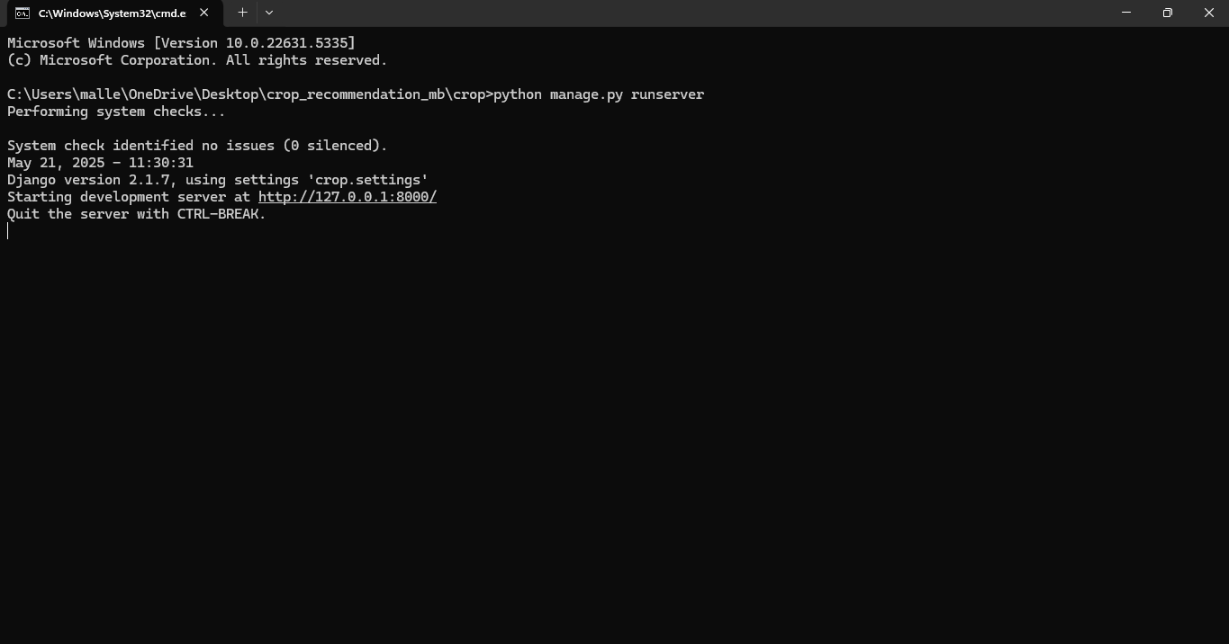

Copy the generated url and paste it in web browser

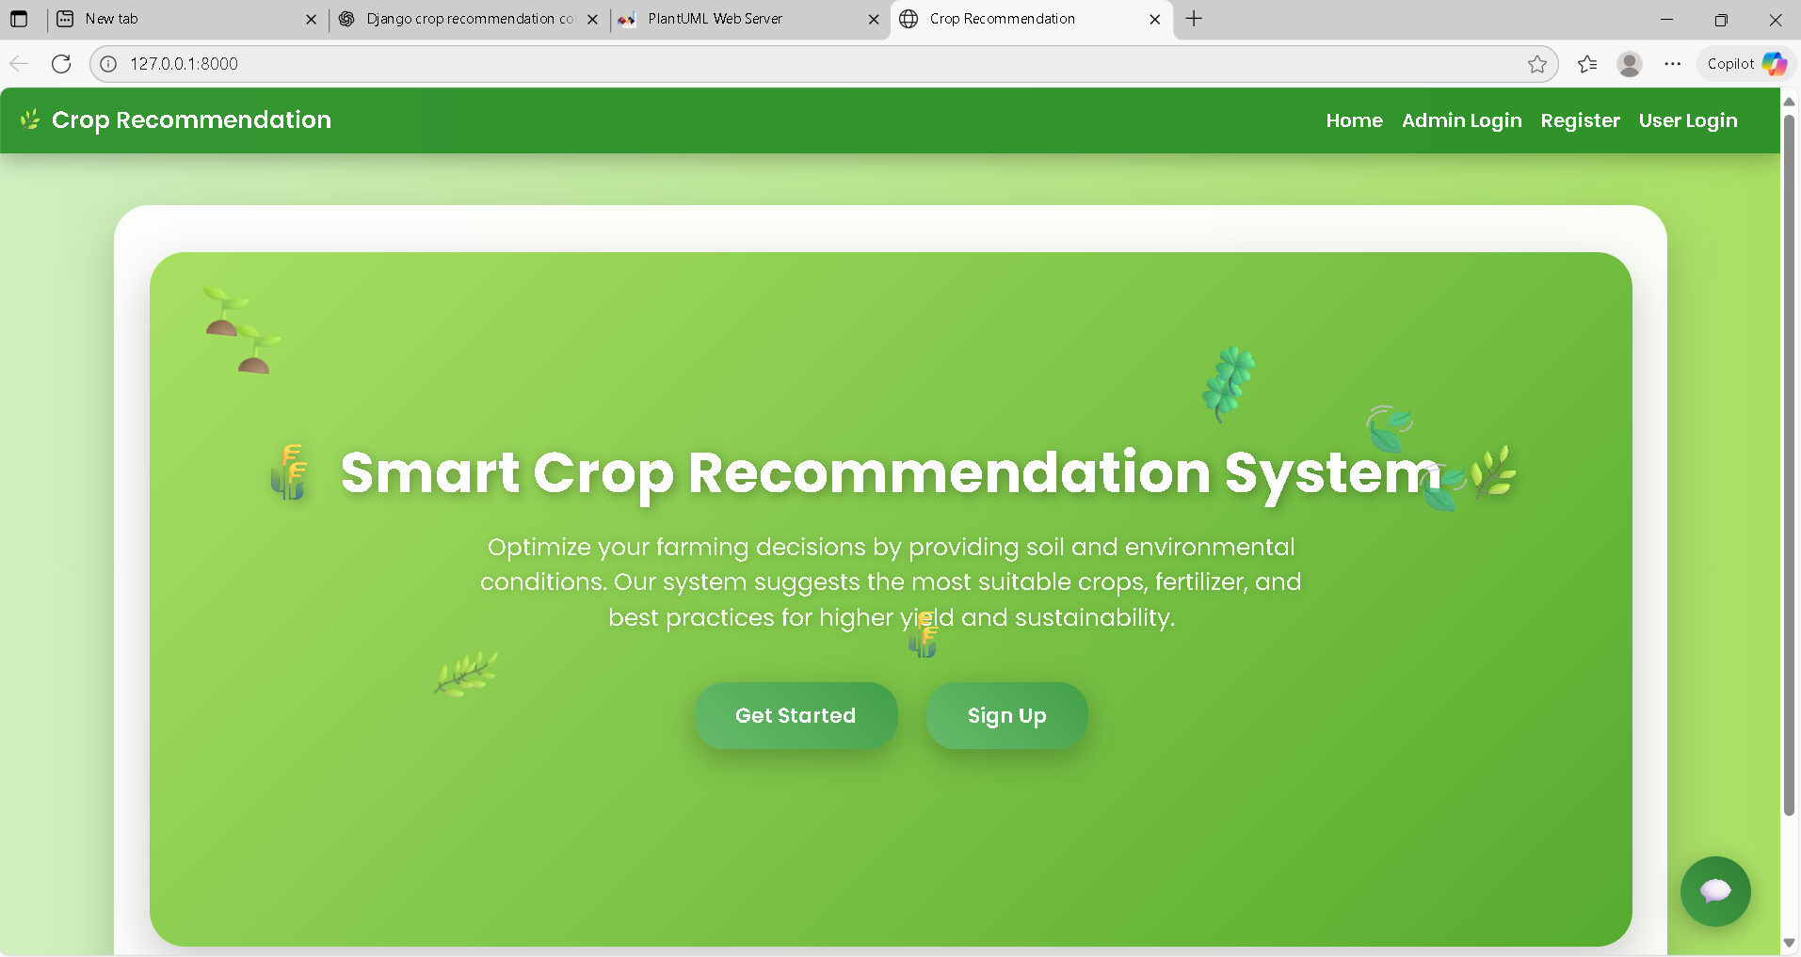

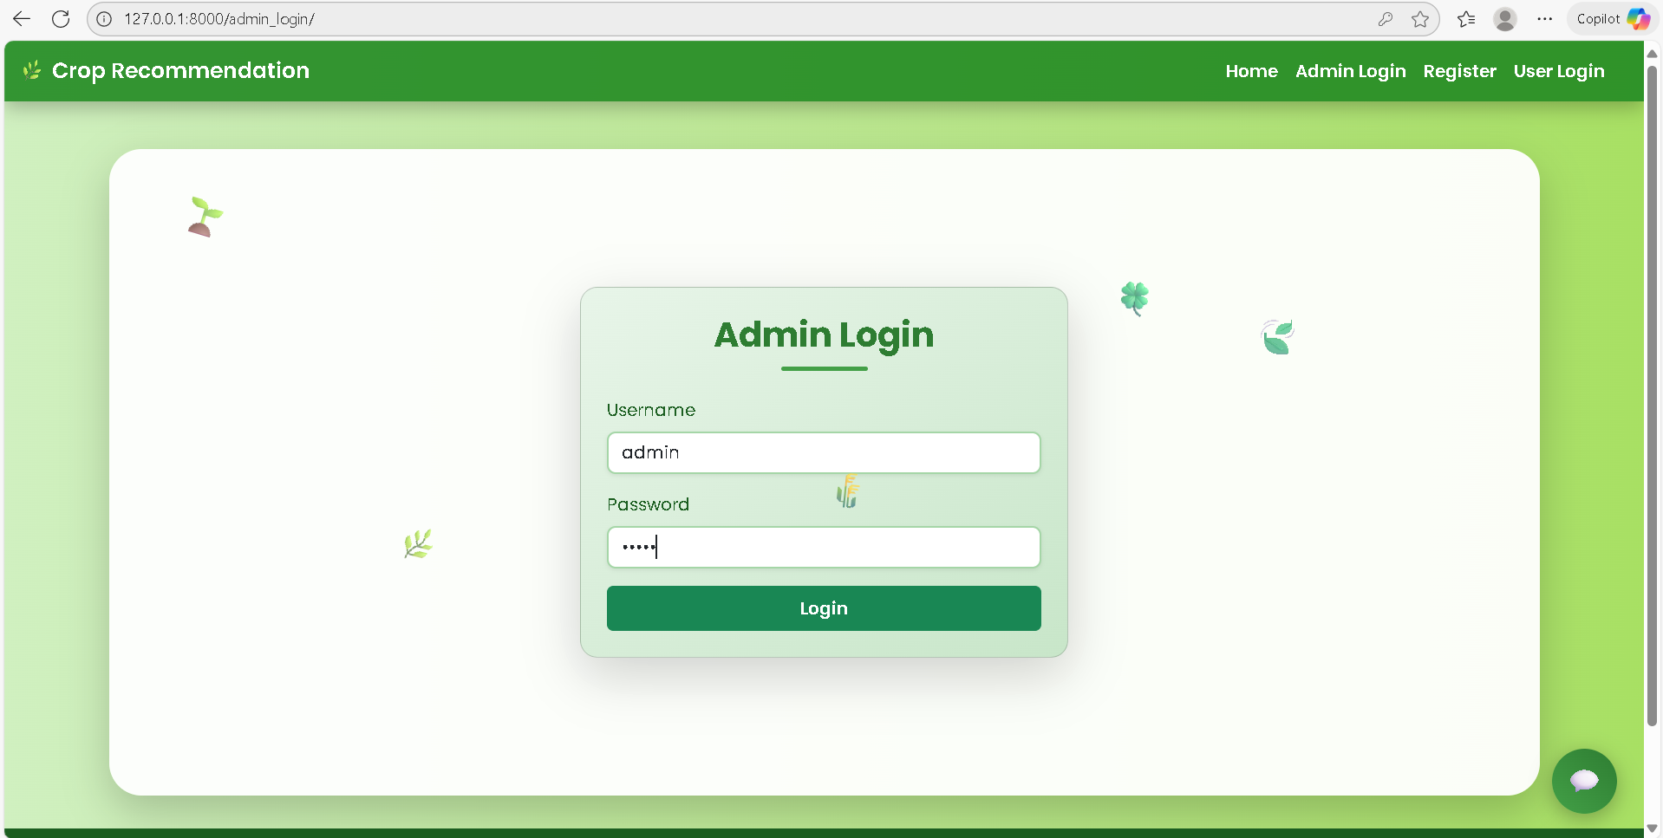

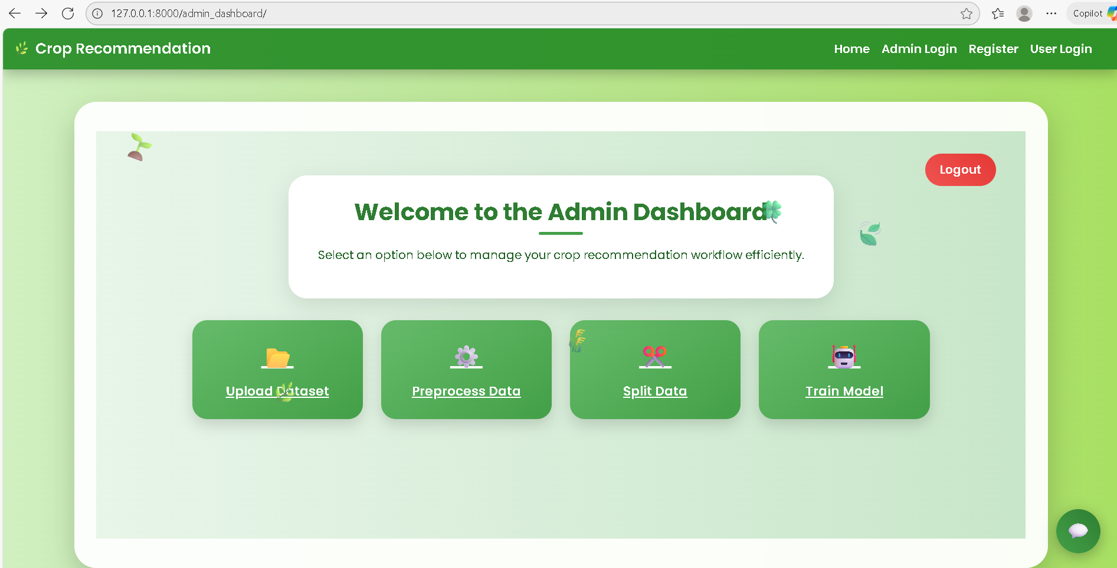

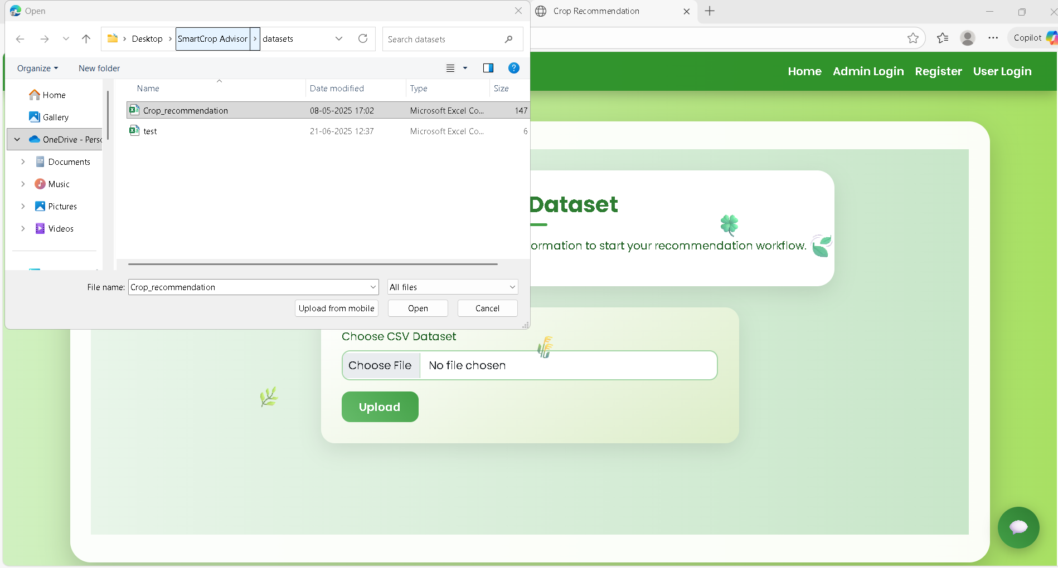

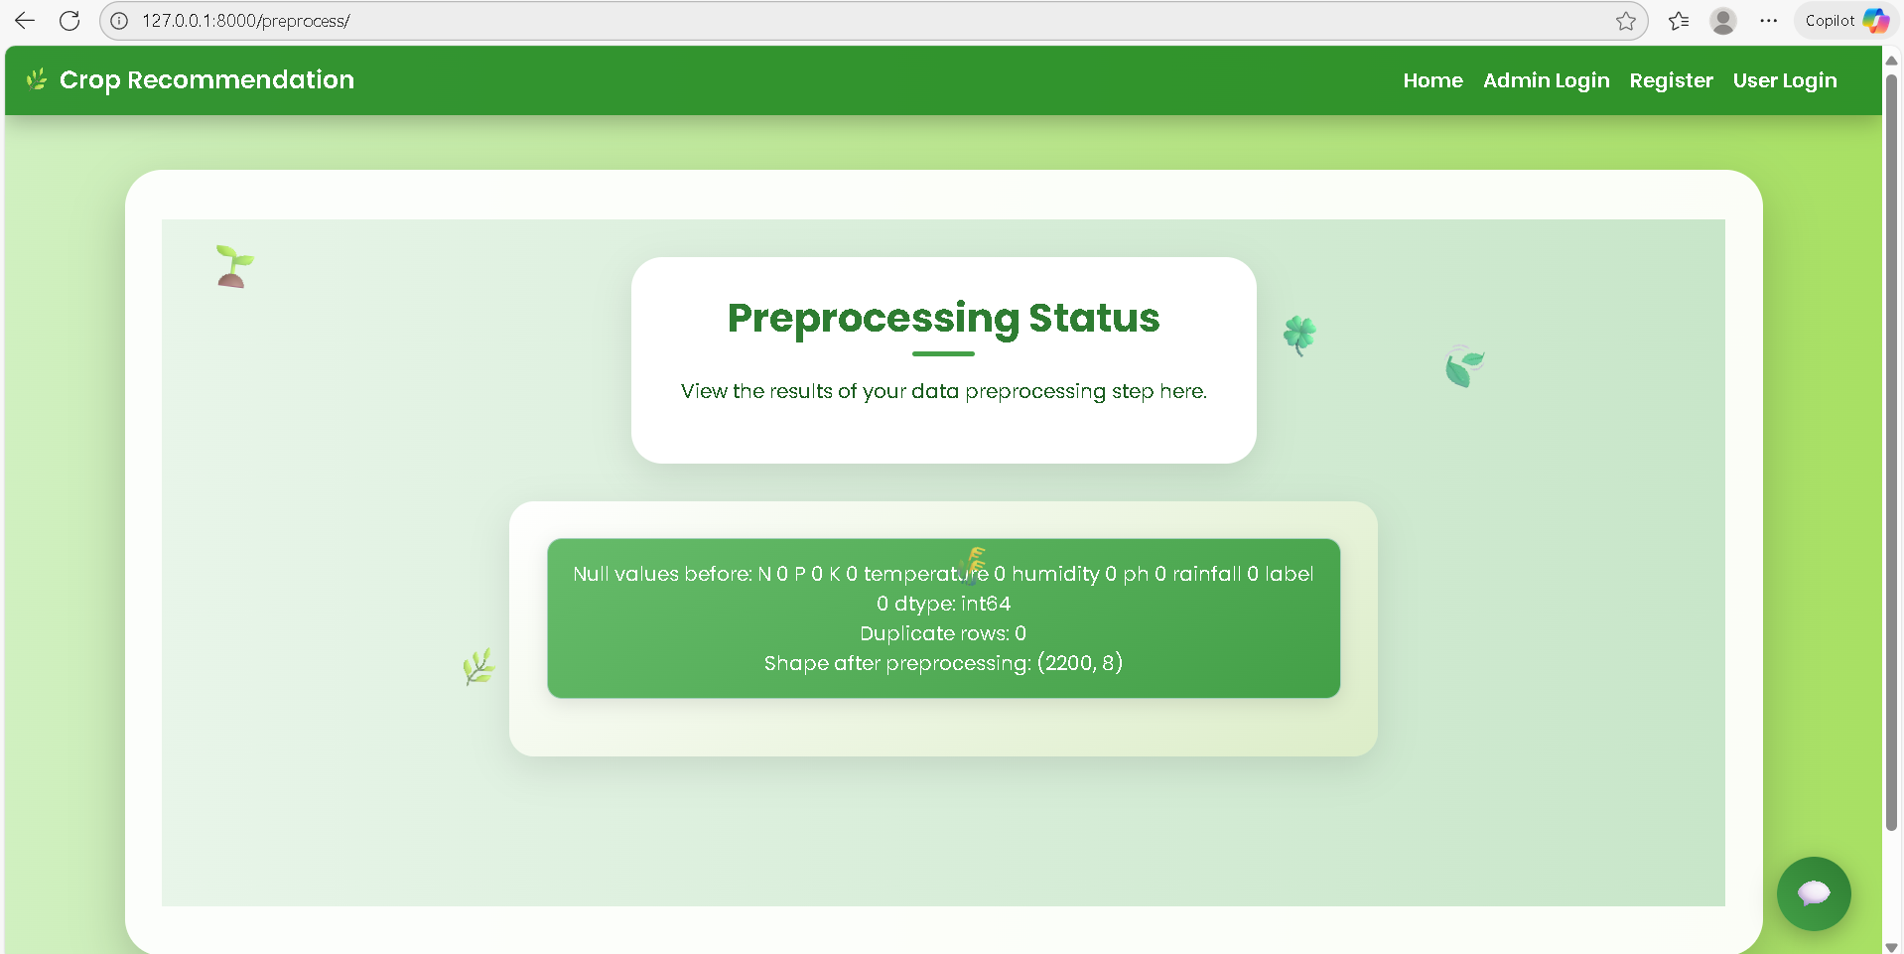

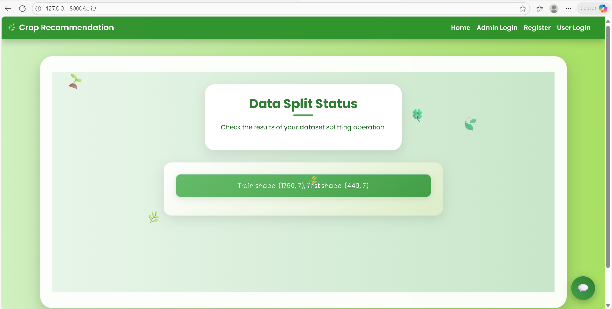

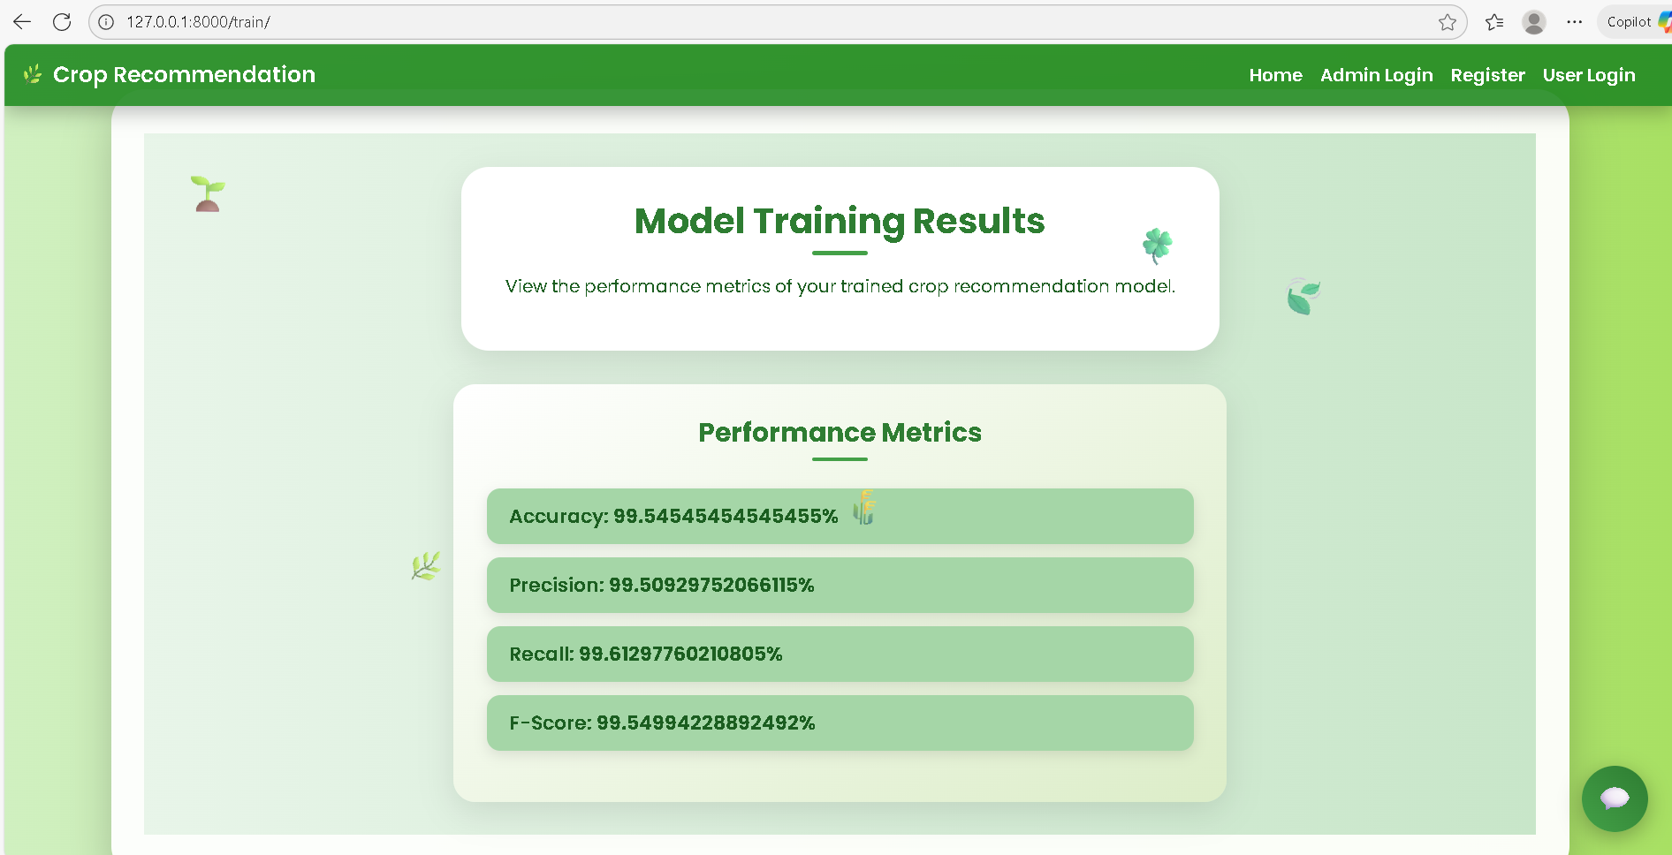

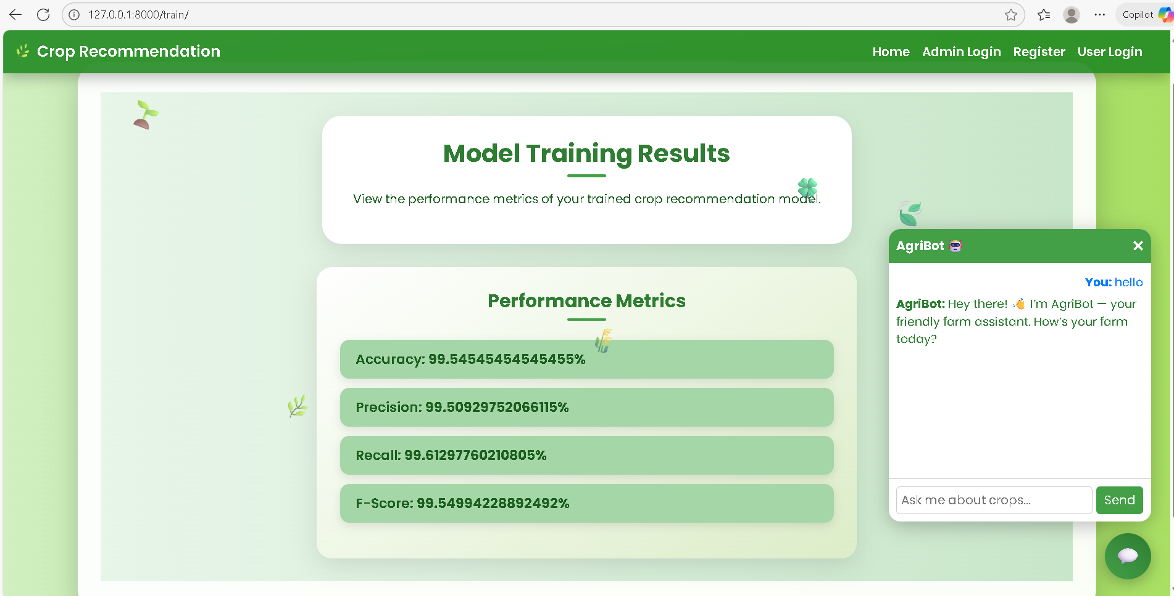

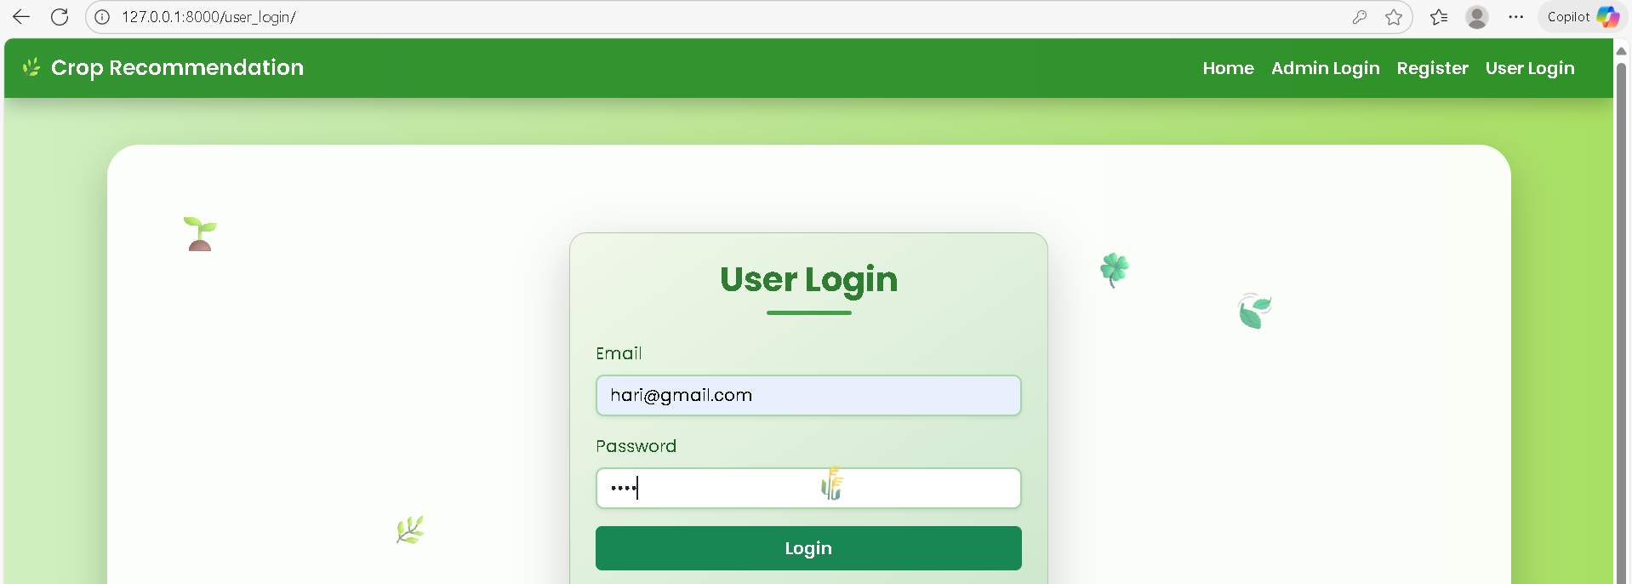

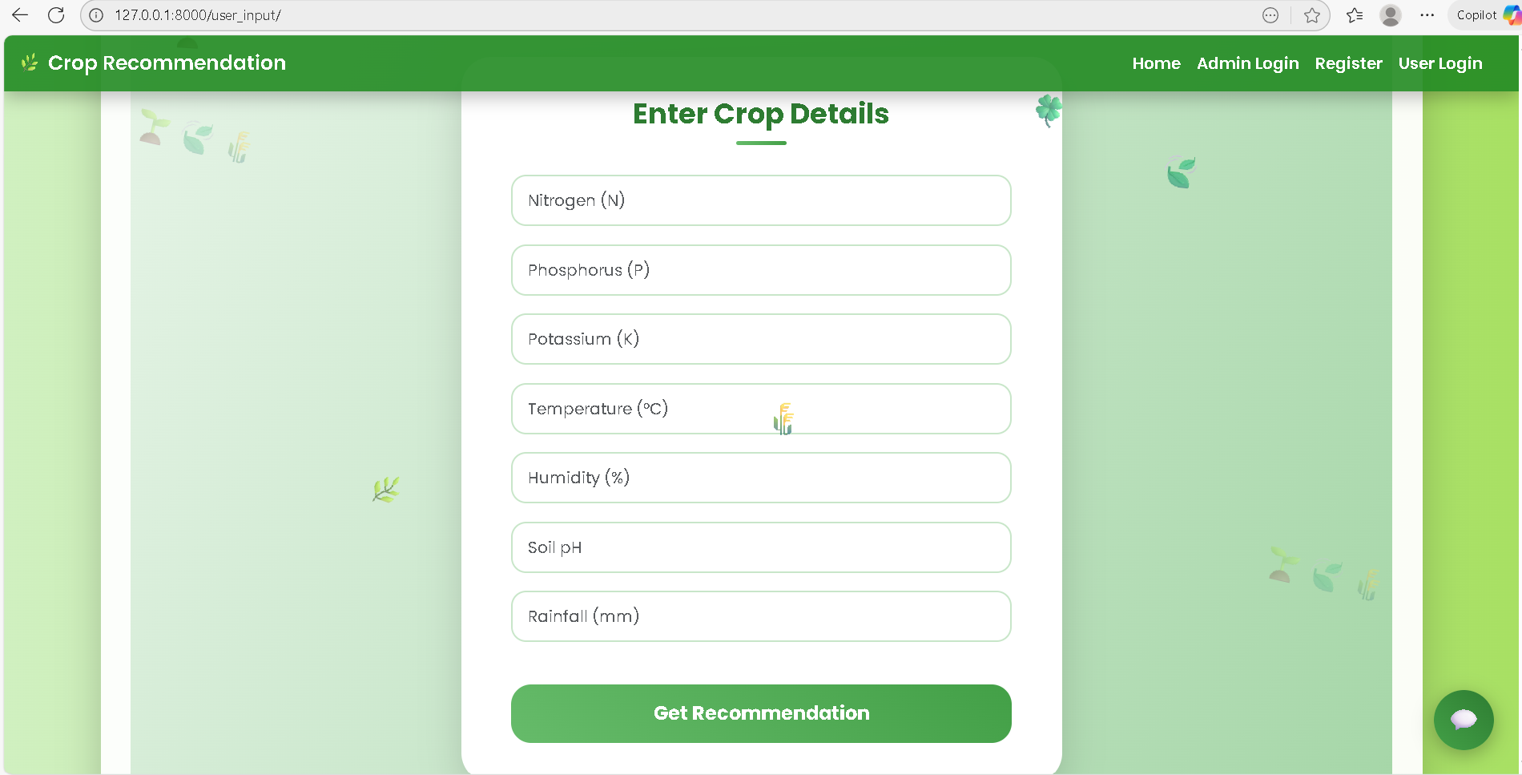

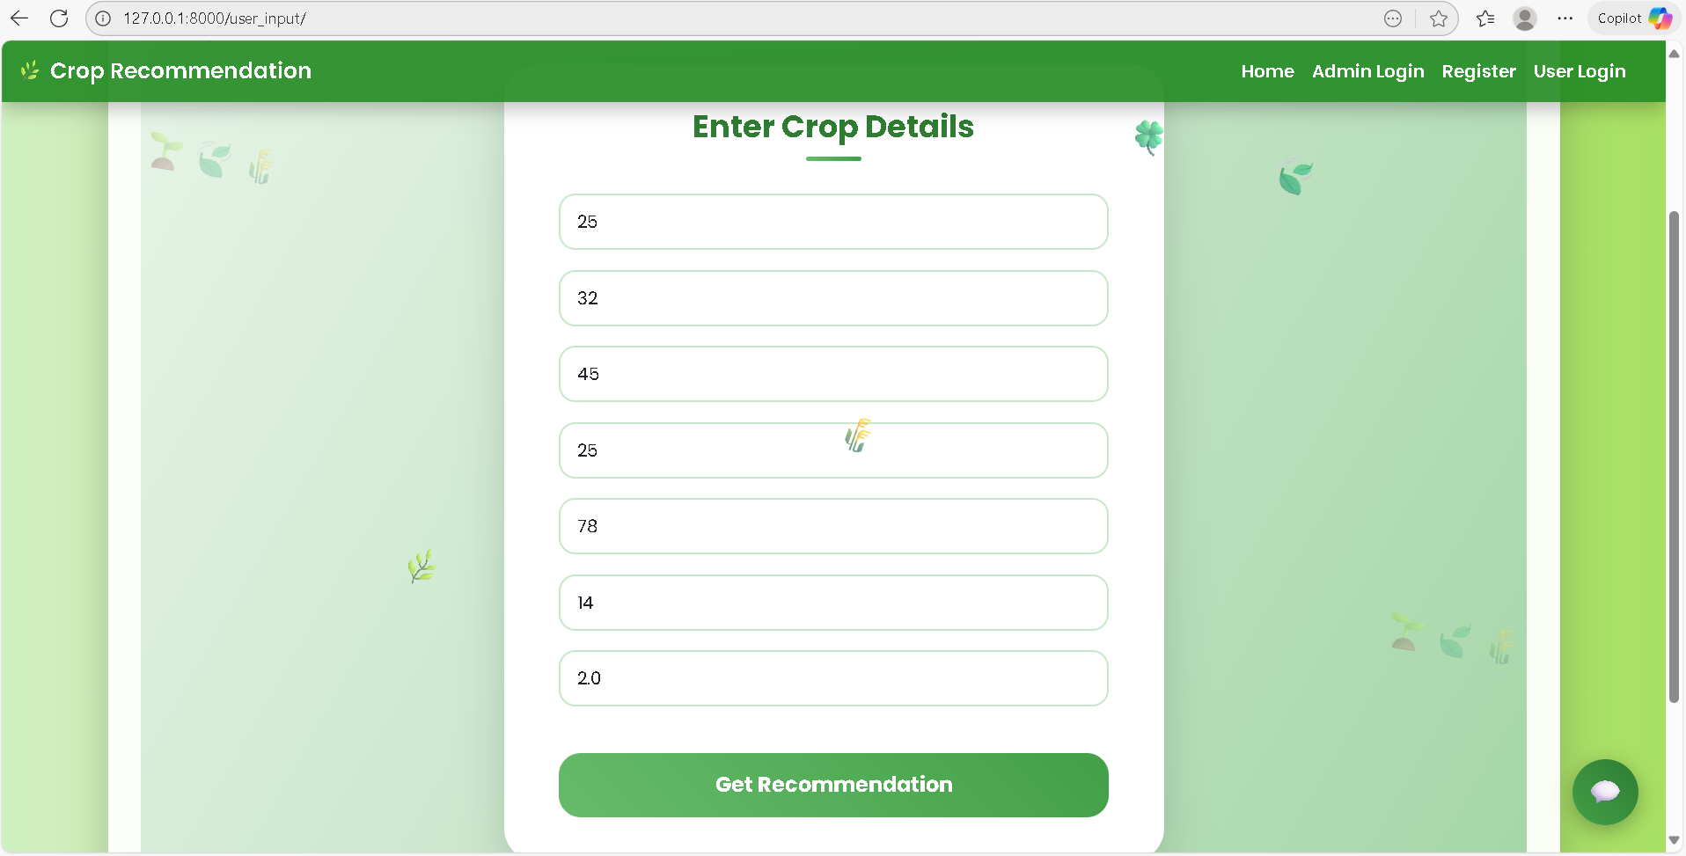

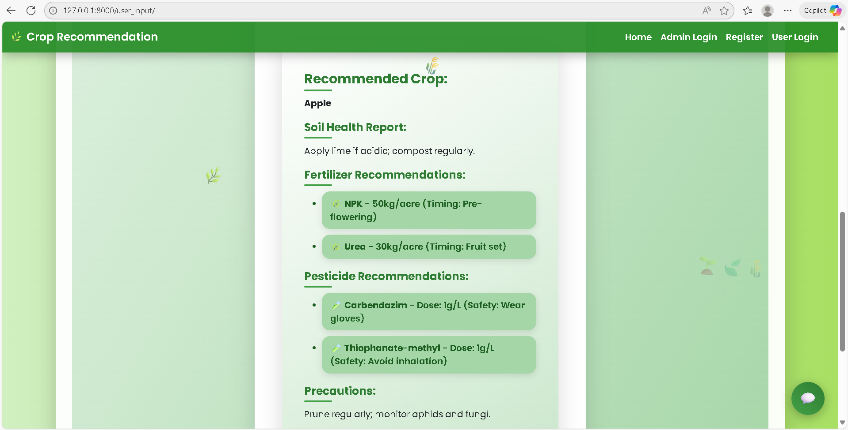

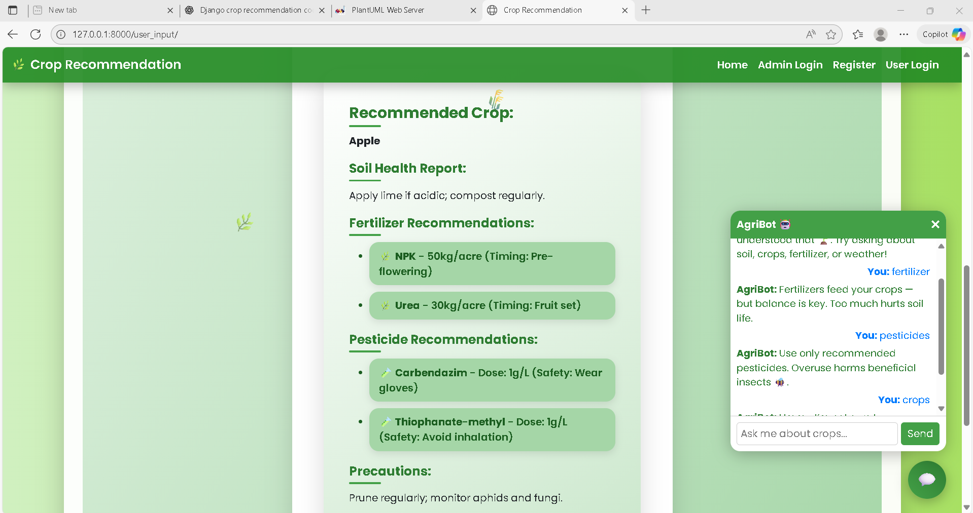

Now first Train our model so login as admin. User name and passwords are admin

After login the admin do the following steps upload dataset, preprocessing, splitting, and Train model respectively.

After training our model login as user. If in case you are the new user complete registration.

After completion of registration login as user using your credentials which are entering in registration step.

After login action you can enter the properties of soil and enter submit button like below way.

After submitting the properties the result will display as below.

# **CONCLUSION**

The proposed **SmartCrop Advisor – Predictive Crop Recommendation & Agro-Management System using Random Forest** effectively addresses the limitations of traditional farming practices and existing agricultural models. By leveraging soil nutrients, weather conditions, and environmental parameters, the system provides farmers with accurate and reliable crop recommendations. Unlike manual decision-making, which is often based on experience or guesswork, this model ensures data-driven precision that minimizes risks of crop failure.

Through the integration of **machine learning (Random Forest classifier)** with a user-friendly Django-based interface, the system not only predicts the most suitable crop but also delivers a complete advisory package. This includes soil health management, fertilizer scheduling, pest control guidance, and marketing strategies. By combining prediction with actionable insights, the platform empowers farmers to improve productivity, reduce costs, and adopt sustainable agricultural practices.

Ultimately, the system enhances **decision support in agriculture**, promotes **precision farming**, and contributes towards **food security** by optimizing crop yield and resource utilization.

# **FUTURE SCOPE OF THE PROJECT**

The **SmartCrop Advisor** system can be further enhanced to address more complex agricultural challenges and provide greater value to farmers. In the future, the model can integrate **real-time IoT sensor data** for parameters such as soil moisture, rainfall, and temperature, ensuring dynamic and more precise crop recommendations. Additionally, incorporating **satellite imagery and remote sensing** will enable large-scale monitoring of soil fertility, pest infestations, and crop health, further strengthening advisory services.

Another potential enhancement is the use of **deep learning models** like CNNs and RNNs for leaf disease detection and weather forecasting, which could be combined with the recommendation system to offer a complete smart farming solution. Moreover, integration with **mobile applications** and support for local languages will make the system more accessible to farmers in rural areas.

Finally, future advancements can include **blockchain for supply chain transparency**, enabling farmers to directly connect with markets, reduce middlemen, and gain better prices for their produce. With such expansions, the system can evolve into a holistic **smart agro-management ecosystem** that drives sustainable agriculture and contributes to global food security.

# **REFERENCES**

1. Aravind, K., & Ashok Kumar, P. (2020). Crop recommendation system for precision agriculture using Random Forest. *International Journal of Computer Applications, 975(8887)*.
2. Khaki, S., & Wang, L. (2019). Crop yield prediction using deep neural networks. *Frontiers in Plant Science, 10, 621.*
3. Singh, V., & Misra, A. K. (2017). Detection of unhealthy region of plant leaves using image processing and genetic algorithm. *International Journal of Computer Applications, 157(4), 24–30.*
4. Ghosal, S., et al. (2018). An explainable deep machine vision framework for plant stress phenotyping. *PNAS, 115(18), 4613–4618.*
5. Chlingaryan, A., Sukkarieh, S., & Whelan, B. (2018). Machine learning approaches for crop yield prediction and nitrogen status estimation in precision agriculture. *Computers and Electronics in Agriculture, 151, 61–69.*
6. Liakos, K. G., et al. (2018). Machine learning in agriculture: A review. *Sensors, 18(8), 2674.*
7. Alam, M. A., et al. (2020). Smart agriculture monitoring system using IoT and machine learning. *International Journal of Scientific & Technology Research, 9(6), 4856–4862.*
8. Pantazi, X. E., Moshou, D., & Bravo, C. (2016). Active learning system for weed species recognition based on hyperspectral sensing. *Biosystems Engineering, 146, 193–202.*
9. Shinde, R., & Patil, R. (2018). Crop prediction system using machine learning algorithms. *International Journal of Advanced Research in Computer Engineering & Technology, 7(3).*
10. Shah, D., & Patel, K. (2019). Smart crop prediction using machine learning. *International Journal of Innovative Technology and Exploring Engineering, 8(6S), 224–228.*
11. Jha, K., Doshi, A., Patel, P., & Shah, M. (2019). A comprehensive review on automation in agriculture using artificial intelligence. *Artificial Intelligence in Agriculture, 2, 1–12.*
12. Mohanty, S. P., Hughes, D. P., & Salathé, M. (2016). Using deep learning for image-based plant disease detection. *Frontiers in Plant Science, 7, 1419.*
13. Shahhosseini, M., et al. (2021). Maize yield prediction with random forest and deep learning using remotely sensed data. *Remote Sensing, 13(2), 207.*
14. Chakraborty, S., & Newton, A. C. (2011). Climate change, plant diseases and food security: an overview. *Plant Pathology, 60(1), 2–14.*
15. Sharma, A., Jain, A., Gupta, P., & Chowdary, V. (2020). Machine learning applications for precision agriculture: A comprehensive review. *IEEE Access, 9, 4843–4873.*
16. Ramesh, D., & Vardhan, B. V. (2015). Data mining techniques and applications to agricultural yield data. *International Journal of Advanced Research in Computer and Communication Engineering, 4(1), 120–124.*
17. Aditya, K., & Chandrasekhar, P. (2018). Agricultural crop recommendation system using Random Forest classifier. *International Journal of Computer Science and Engineering, 6(11).*
18. FAO (2019). The State of Food and Agriculture. *Food and Agriculture Organization of the United Nations.*
19. USDA (2020). Precision Agriculture: Technologies and Global Markets. *U.S. Department of Agriculture Report.*
20. Kaur, P., & Dhaliwal, M. (2019). A review on crop yield prediction using machine learning approaches. *International Journal of Computer Applications, 975(8887).*